UNIVERSITY OF THE WITWATERSRAND, JOHANNESBURG

SCHOOL OF MOLECULAR AND CELL BIOLOGY



MOLECULAR AND CELL BIOLOGY IIA: SCIENTIFIC PRACTICE (MCBG2036)

COURSE INFORMATION

AND

PRACTICAL SCHEDULE

2018
SCHOOL OF MOLECULAR AND CELL BIOLOGY

MOLECULAR AND CELL BIOLOGY IIA: SCIENTIFIC PRACTICE (MCBG 2036)
CLASS ARRANGEMENTS 2018

N.B. Students must regularly check (possibly daily), at least weekly, the eLearning platform SAKAI and the notice board outside the OLS Laboratory for information pertaining to the Scientific Practice IIA course.
The Molecular and Cell Biology IIA: Scientific Practice Course (MCBG 2036) is designed to lay the foundation for scientific practice in the molecular biosciences. The focus, therefore, is on the content knowledge as well as on laboratory techniques and skills considered essential for biomolecular scientists.

This course has been designated a writing intensive course. This is because writing is used as a tool to promote critical thinking. Therefore, students will do informal, exploratory writing during lectures, on SAKAI and during practical’s. In addition, students will be required to complete a number of formal writing assignments during the year.

This course uses the PRS Interwrite interactive technology for teaching. Therefore, every student registered for the course will be required to hire a personal response system keypad (clicker) from the school. You will be issued with a keypad on Monday 5 February at 10:00 when you collect your practical manual. You will be required to pay R150 (into account 001.408.8757101.5122609.MCBD080) to the cashier in Senate House and take the receipt to Ms. N Jamnadas in the MCB administration office on the ground floor of Gate House. Failure to pay or return the keypad will mean that your results will be withheld. If you lose the clicker you will have to pay the full price of the clicker which is R600.00

Lecture Times and Venues (Slot C):

Day | Time | Venue
Wednesday: | 08h00-08h45, 09h00-09h45 | SHB 5
Thursday: | 10h15-11h00, 11h15-12h00 | SHB 5
Friday: | 12h30- 13h15 | SHB 5

Prescribed Textbooks:

1. John McMurry (2015, 2011 Cengage Learning). 3 edition.
Organic Chemistry with Biological Applications
ISBN: -978 144 797 0309

AND

2. Book bundle (ISBN 978 144 797 0309) consisting of:

a) Reed, Rob, Holmes D, Weyers, Jonathan & Jones, Allen
Practical Skills in Biomolecular Sciences
Pearson Education Limited, England.

b) Tortora, Funke and Case:
Microbiology an Introduction 11th edition,
Pearson International

* NOTE: Block 1 Scientific Practice (Chemical Aspects) will use the prescribed books for MCBG IIB Concepts:
(Consult the relevant information sheet)

Assessment: There will be at least one major test per block. Continuous and formative assessment will take place during tutorials, lectures and practical sessions, in the form of pre-practical tests, workshops, tutorials, writing assignments and practical reports.

Major Tests: Test 1 – 19 March Venue: Exams Hall
Test 2 - 14 May Venue: T.B.C.
Test 3 – 27 August Venue: Flower Hall
Test 4 – 9 October Venue: SHWWDH

Examinations:
The first semester will be examined by a 3-hour paper and the second semester will be examined by a 1.5-hour paper. To apply for a deferred examination, you will need to apply on line to the Faculty within 3 working days of the examination.

Mark Allocation: Final examination 50%; Class mark 50%

Class mark compiled from:
Major block tests = 50%; Assignments, practical reports and tutorials = 35%; pre-practical tests = 15%

Practicals: One session per week: On a Monday from 14h00 to 17h15 in the Ground Floor, OLS laboratory.

PRACTICAL MANUALS AND OTHER HANDOUTS MUST BE COLLECTED ON MONDAY, 5th FEBRUARY AT 10H00 FROM OLS, GROUND FLOOR LABORATORY.

NOTE: A COMPULSORY WORKSHOP WILL BE HELD ON MONDAY, 5th FEBRUARY AT 14H00 IN VENUE SHB5

Medical Certificates: Absence from a practical, tutorial or test will be condoned only if an official School verifiable medical certificate is handed to the School administrator in GH001 within 3 working days of that absence. Records will be kept of attendances during laboratory periods and spot checks made to ensure that you are present during tutorials.

Satisfactory Performance: You must attend all tutorials and practicals, hand in all assignments and practical reports and write all tests. A class mark of 40% must be achieved in order to be eligible to write the June examination.

NO SATISFACTORY PERFORMANCE CERTIFICATE WILL BE ISSUED UNLESS YOU HAVE FULFILLED THE ABOVE REQUIREMENTS.

NB: Students with a course semester mark of less than 40% will not be allowed to present themselves for examination and will be required to deregister from the course

Please note carefully, that the number of places in 2019, 3rd year major courses are restricted. Unfortunately, this is the product of limited laboratory space available for the requisite practical components. A direct consequence is that successful completion of the prerequisite course Applications (MCBG2033) will not necessarily guarantee you a place in the 3rd year major of your choice.

The 3rd year degree courses offered in the School of Molecular and Cell Biology will be filled on the basis of merit.

COURSE INFORMATION:
Course content:
- Scientific practice including scientific reasoning (deductive, inductive and abductive arguments), experimental design, data reporting, scientific report writing (+ assessing information, citing and plagiarism).
- The chemical and physical basis of life including cellular chemistry, units of measurements, solutions, weak electrolytes, buffer solutions, functional groups, biomolecules like carbohydrates and lipids.
- Techniques used in the molecular biosciences including spectroscopy, chromatography, electrophoresis, centrifugation, cell culture, microscopy, immunotechniques.
- Introduction to microorganisms: bacteriology and associated laboratory techniques; viruses and immunology; fungi.
- Fundamental principles of molecular genetics like nucleic acid purification, production of DNA fragments, separation and identification of specific nucleic acid molecules using blotting and hybridization techniques (Southern, Northern, Western), sequencing; PCR and related applications; genetic engineering techniques; Introduction to computational biology.

Lecturers:
Professor Y Sayed - Course coordinator – (GH 420)
Professor V Gray (OLSB 014)
Professor M Kaur (GH 508)
Dr D De Assis Rosa (GH 700)
Professor G Bouwer (BB 228)
Professor C Rey (BB 223b)
Dr A Botes (BB 208)

Enquiries relating to the organization of the course should be made to Professor Y Sayed (GH420).
Course registration problems should be addressed to Mrs. Louise Giustinoni, GH001.
P.T.O. for Book list

SCIENTIFIC PRACTICE
(Estimated Students: 220)
1st & 2nd Semester Blocks 1 – 4
 | Prescribed
John McMurry (2015, 2011 Cengage Learning).  3rd edition. | Organic Chemistry with Biological Applications ISBN: -13:978-1-285-84291-2 | CENGAGE Learning
 | Recommended
 | Book Bundle ISBN 978 144 797 0309
Reed, Rob, Holmes, D, Weyers, Jonathan & Jones, Allan | Practical Skills in Biomolecular Sciences 3rd edition | Pearson Education
Reed, Rob, Holmes, D, Weyers, Jonathan & Jones, Allan | AND | Pearson Education
Tortora, Funke and Case | Microbiology an introduction 9th edition
 | Recommended
Cottrell, S (2011) | Critical Thinking Skills - Developing Effective Analysis and Argument 2e | Palgrave Macmillan
 | ISBN: 978-0-230-28529-3
 | Recommended
Watson, Baker, Bell, Gann, Levine, Losick | Molecular Biology of the Gene (7th edition) | Pearson
 | ISBN: 978-0-321-76243-6

MOLECULAR AND CELL BIOLOGY IIA: SCIENTIFIC PRACTICE (MCBG2036) – 2018

Welcome to the Molecular and Cell Biology IIA: SCIENTIFIC PRACTICE Course. This course is designed to lay the foundation for scientific practice in molecular biosciences. The focus is, therefore, on the content knowledge as well as on laboratory techniques and skills considered essential for biomolecular scientists.

The course is designated a writing intensive course. This is because writing is used as a tool to promote critical thinking. Therefore, one of the interactive ways in which it is taught is to promote critical engagement using writing (CEW). You will, therefore, do informal, exploratory writing during lectures on the Sakai discussion forum and during practical sessions. In addition, you will be required to complete a number of formal writing assignments during the year. You will also be using clickers.

Course Information:

Course Co-ordinator Prof Sayed (yasien.sayed@wits.ac.za; Office: Gate House 420)

Textbooks: John McMurry (2015, 2011 Cengage Learning). 3rd edition. Organic Chemistry with Biological Applications. ISBN 978 144 797 0309

Book Bundle ISBN 978 140 827 0448 consisting of:
- Reed, Rob; Holmes, David; Weyers, Jonathan; Jones, Allen (2013): Practical Skills in Biomolecular Sciences (4th edition), Pearson Education Limited, England

- Tortura, Funke and Case (2013): Microbiology: An Introduction (11th edition)

Lecturers: Block 1 Prof Sayed (yasien.sayed@wits.ac.za; OFFICE: GH 420)
Prof Gray (vincent.gray@wits.ac.za; OFFICE: OLSB 014)

Block 2 Prof Kaur (mandeep.kaur@wits.ac.za; OFFICE: GH 508)
Dr De Assis Rosa (debbie.deassisrosa@wits.ac.za; OFFICE: GH 700)

Block 3 Prof Bouwer (gustav.bouwer@wits.ac.za; OFFICE: BB 228)
Prof Rey (chrissie.rey@wits.ac.za; OFFICE: BB 223b)
Dr Botes (angela.botes@wits.ac.za; OFFICE: BB 208)

Block 4 Prof Kaur (mandeep.kaur@wits.ac.za; OFFICE: GH 508)

GH = Gate House, OLSB = Oppenheimer Life Sciences Basement and BB = Biology Building

Assessment: There will be at least one major test per block. Continuous and formative assessment will take place during tutorials, lectures and practical sessions, in the form of tests, writing, inquiry, other assignments and practical reports.

Major Block Tests: Block 1 Test: Monday, 19 March. 2pm; Exams Hall Block 2 Test: Monday, 14 May. 2pm; Flower Hall Block 3 Test: Monday, 27 August, To Be Confirmed Block 4 Test: Tuesday, 9 October. 10.30am - 12pm; SHWWDH

To apply for a deferred test, you will need to provide an original medical certificate within 3 working days of the original test date to Mrs Louise Giustinoni (GH001).

Examinations: Summative assessment for each semester will include a 3-hour formal exam. To apply for a deferred examination, you will need to complete the Faculty’s official forms within 3 working days of the original examination date (see notice board for details). Information pertaining to the deferred examinations will be communicated through Sakai.

Mark Allocation: Final examination 50%; Class mark 50% (the class mark will be compiled from: major block tests – 50%; assignments and tutorials – 25%; practical reports and practical tests – 25%).

Practicals: Practical work is an important part of the course. This is because all knowledge and theory in science has originated from practical observation and experimentation and, as budding scientists, it is essential that you learn to design and perform experiments successfully. You may be given a short practical test before or after the afternoon contact sessions to make sure that you have prepared for or have understood the practical session and that you understand and can apply the theory that has been covered during the week. Your practical mark will be a composite mark comprised mainly of results from these tests and practical reports. Unless otherwise stated, practical reports are to be signed by your TA at the end of the practical session before you leave the laboratory. In some instances, you may be required to complete sections at home for submission the next week.

You will get the most out of practical sessions if you prepare well in advance. Do not go into a practical session assuming that everything will be provided without any input on your part. Before you enter the laboratory make sure that you understand the purpose of the practical and the particular skills involved. In some cases, you will require to design your own experiments. This must obviously be done before you enter the laboratory.

All practical work must be carried out with safety in mind, to minimize the risk of harm to you and to others - SAFETY IS EVERYONE’S RESPONSIBILITY! Make sure that you familiarize yourself with the general laboratory safety procedures before you enter the laboratory (on Sakai).

Plagiarism: The following transcript is based on material in How to Write Better Essays, by Bryan Greetham (2001).

Plagiarism is presenting someone else’s ideas or arguments as your own, or taking credit for someone else’s work. Plagiarism is considered as a form of academic dishonesty; it is illegal and unethical. Don’t commit plagiarism intentionally (e.g. if you are pressed for time). Never cut and paste information from electronic sources. The following ‘six-point code’ could help you decide when and how to cite. It might be useful to write out the points and keep them with you as a quick reference. Basically, you need to provide a reference for:

1. Distinctive ideas (this means you have to cite even when you are rewriting in your own words)
2. Distinctive structure or organizing strategy
3. Information or data from a particular source
4. Verbatim phrase or passage
5. Anything that’s not common knowledge
6. Finally, if in doubt, cite!

All formal scientific reports and writing assignments must be submitted to Turnitin®. If your report or assignment displays a similarity index above 15%, you will be given a zero for the report or assignment in question.

Satisfactory Performance:

You must attend all tutorials and practicals, hand in all practical reports and write all tests: absence is condoned only by a medical certificate or some other satisfactory reason. Medical certificates must be handed to the Mrs Giustinoni (GH001) within 3 working days. Records will be kept of attendances during laboratory periods and spot checks made to ensure that you are present during the tutorials. No satisfactory performance certificate will be issued unless you have given satisfactory performance.

NB: Students with a course semester mark less than 40% will not be allowed to present themselves for examination and will be required to deregister from the course.

Medical Certificates: Absence from a practical, tutorial or test will be condoned only if an official School medical certificate is handed to the School administrator in GH001 within 3 working days of that absence. Records will be kept of attendances during laboratory periods and spot checks made to ensure that you are present during tutorials.

D.P. Certification: You must attend all tutorials and practicals, hand in all assignments and practical reports and write all tests.

NO DUE PERFORMANCE CERTIFICATE WILL BE ISSUED UNLESS YOU HAVE FULFILLED THE ABOVE REQUIREMENTS.
MEDICAL CERTIFICATE

In support of application for a deferred test in the School of Molecular and Cell Biology, Wits University

A deferred test is not granted automatically by the School. Fair and objective medical evidence is essential to assist us in evaluating an application for a deferred test. We thank you for your cooperation.

I certify that I attended to: .......................................................................................... (full names)

on: ......................................................................................(please give time and dates)

DETAILS OF ILLNESS

Date of onset of current illness: .......................................................................................

Symptoms: .........................................................................................................................

...........................................................................................................................................

Diagnosis: ..........................................................................................................................

...........................................................................................................................................

RECOMMENDATION ON FITNESS TO WRITE A FORMAL TEST

In my opinion the above student is/was:

(a) unfit on account of illness.................................................................. (signature)
OR (b) unfit on account of acute anxiety state.............................................. (signature)
OR (c) medically fit........................................................................................ (signature)
to write the test at ................................. (time) on................................... (date)
(Note: Your signature is requested here to prevent unauthorized changes to the above statement).

PARTICULARS OF MEDICAL PRACTITIONER

Name/designation: ...........................................................................................

Address: ...........................................................................................................

..........................................................................................................................

Telephone number: ....................................................

The above named student has been a patient of mine for........ (years) / ........ (months)

Signature: ........................................ Date: ........................... Medical Practitioner's Stamp

1PROCEDURE TO BE FOLLOWED AT MCB IIA AND MCB IIB PRACTICALS

Unless notified to the contrary, all practicals will be held in the Ground Floor Laboratory, Oppenheimer Life Sciences Building. Venues for workshops, presentations, and tutorials will be OLS2 unless indicated otherwise by the lecturer responsible,

Please take note of the following procedures which are to be followed at practicals.

- Each student has been allocated a bench space. Please consult the list on the notice board outside the lab before the first practical to see where you will be working.

- You will have been allocated a TA - (according to where you will be working.) Your TA will be there to assist you. He/she will mark the register, will be there to explain and help you with the practical, demonstrate the use of equipment, find extra solutions etc. The TAs will also mark your practical tests and some practical reports and give you feedback on how you are doing. TAs will be available during the practical to explain certain theoretical aspects of the practical should this be necessary.

- Practicals will start promptly at 14h00. You will be required to complete a short (15 minute) test at the start or at the end of most practicals. As soon as you enter the laboratory, go to your TA and have yourself marked present and wait for instructions. As soon as you have completed your test and your TA has finished explaining or demonstrating the use of equipment etc. you can begin your practical work.

- All safety procedures must be followed during the practicals. This means that you must have lab coats and safety goggles, wear CLOSED SHOES and long pants or skirts and be familiar with the safety procedures (see page 12). When it is necessary, work must be carried out in fume hoods. You will be advised as to when this is the case.

- Practical results, graphs and calculations must be completed and shown to your TA before you leave the laboratory. Certain practicals will be written up as formal scientific reports. Time has been allocated for most report write ups – but occasionally you will be required to complete a practical report or writing exercise at home. If this is the case the report or assignment must be submitted in the box on the ground floor Gate House, the following week at a time specified by the lecturer in charge. No late submissions will be accepted. (NB: Work may not be pushed under the door of the lecturer’s office). Details are given in the course profiles.

Practicals are compulsory for attainment of due performance (DP). If you are absent from a practical due to illness or any other cogent reason, please hand in a doctor’s certificate or a letter of explanation to Mrs Selepe (in the administrative office – Gate House, ground floor) as soon as possible.

LABORATORY SAFETY - GENERAL GUIDELINES
Locate and, when appropriate, learn to use exits, fire extinguisher, and fire blanket (and know what to do in case of fire - how to sound the alarm, where the fire exits are, and where to gather), Also locate the chemical shower, eyewash bottle, first aid kit, broken glass container, and cleanup materials for spills.

Protective clothing should be worn at all times - i.e. laboratory coats (buttoned up), closed shoes, plus safety glasses if there is any risk to the eyes. Confine long hair, loose clothing, and dangling jewelry. Cover any cuts or scrapes with a sterile, water-proof bandage before attending the laboratory.

Upon entering the laboratory, organize your work area. Place all books, bags etc. in designated areas, not on bench tops or in the aisles between the lab benches. Accidents are more likely to occur in a cluttered area.

Never, smoke, eat, drink, or apply cosmetics in the laboratory, because of the risks of contamination by inhalation or ingestion.

Be sure that all open flames are at a distance from any flammable materials such as alcohol, acetone or paper. Never leave heat sources unattended. When using hot plates, note that there is no visible sign that they are hot (such as a red glow). Always assume that plates are hot. Use an appropriate apparatus when handling hot glassware.

Do not perform unauthorized experiments. Do not use equipment without instruction.

Take care when handling glassware. Do not pick up broken glassware with your hands. Use a broom and dustpan and discard the glass in designated glass waste containers; never discard with paper waste.

Do not allow any liquid to come into contact with electrical cords. Handle electrical connectors with dry hands. Do not attempt to disconnect electrical equipment that crackles, snaps, or smokes.

Learn the warning symbols for specific chemical hazards. Use a chemical fume cupboard for hazardous materials. Make sure that the fume hood is working and then open the front only as far as is necessary. Keep chemicals away from direct heat or sunlight.

Work in a logical, tidy manner and minimize risks by thinking ahead. Properly label all of the materials to be used in the experiment. Tape plates or tubes together. All dirty and used glassware should be returned promptly to the receptacles provided or washed and placed in the lockers immediately after use. Do not accumulate unnecessary glassware.

Report all spills and accidents to your instructor immediately. If you spill reagents on your bench, be sure to wipe them immediately. Wash skin immediately and thoroughly if contaminated by chemicals or microorganisms.

Always clear up at the end of each session. This is an important aspect of laboratory safety - Leave the laboratory clean and organized for the next student. This includes wiping the bench clean. Microscopes must always be returned to their proper storage place. Any damage or defect in the microscope should be reported immediately. Lenses must be cleaned with tissue paper and ethanol to remove immersion oil.

Wash your hands with liquid or powdered soap before leaving the laboratory.

Check that gas taps are switched off.

MOLECULAR AND CELL BIOLOGY IIA: LECTURING OUTLINE FOR SCIENTIFIC PRACTICE (Blocks 1, 2 and 3 = C diagonal; Block 4 = A diagonal)

BLOCK 1: Monday 5 February – Friday 23 March (34 days)

Week 1: Mon 5 – Fri 9 Feb (Prof Sayed)

Mon 5 14h00-17h00 LABORATORY SESSION: 14h00 COURSE OVERVIEW; 15h00 USE OF GILSON-TYPE PIPETTES AND SHORT SOLUTION CHEMISTRY DIAGNOSTIC BENCHMARKING TEST
Tues 6 10h15-11h00 Accessing information – Salome Potgieter – Principal Librarian
11h15-12h00 Accessing information – Salome Potgieter – Principal Librarian
Wed 7 8h00-8h45 Solutions, concentrations, dilutions
9h00-9h45 Solutions, concentrations, dilutions
12h30-13h15 Laboratory practice, safety and biosafety
Thurs 8 10h15-11h00 Water, acids and bases
11h15-12h00 Water, acids and bases
Fri 9 12h30-13h15 Tutorial on solutions, acids, bases

Week 2: Mon 12 – Fri 16 Feb (Prof Sayed)

Mon 12 8h00-8h45 Scientific reasoning – deductively valid arguments
9h00-9h45 Inductive and abductive arguments
14h15-17h00 LABORATORY SESSION: STEREOCHEMISTRY TUTORIAL
Wed 14 8h00-8h45 pH, pKa, and buffers; Henderson-Hasselbalch equation
9h00-9h45 pH, pKa, and buffers; Henderson-Hasselbalch equation
Thurs 15 10h15-11h00 Titration curves - weak acids
11h15-12h00 Titration curves - weak acids
14h00-17h00 Writing workshop
Fri 16 12h30-13h15 Tutorial on titration curves practical

Week 3: Mon 19 – Fri 23 Feb (Prof Sayed)

Mon 19 14h15-17h00 LABORATORY SESSION: pH, pK_{a}, TITRATION CURVES AND BUFFERS
Tues 20 10h15-11h00 Experimental design
11h15-12h00 Experimental design
Wed 21 8h00-8h45 Thermodynamics; forces; equilibrium
9h00-9h45 Thermodynamics; forces; equilibrium
12h30-13h15 Measurement - reliability and accuracy
Thurs 22 10h15-11h00 Functional groups
11h15-12h00 Functional groups
Fri 23 12h30-13h15 Functional groups

Week 4: Mon 26 Feb – Fri 2 Mar (Prof Sayed)

Mon 26 14h15-17h00 LABORATORY: REACTIONS OF ALDEHYDES AND KETONES
Wed 28 8h00-8h45 Functional groups
9h00-9h45 Functional groups
Thurs 1 10h15-11h00 Carbohydrates
11h15-12h00 Carbohydrates
Fri 2 12h30-13h15 Carbohydrates
Week 5: Mon 5 – Fri 9 Mar (Prof Sayed/Prof Gray)

Mon 5 14h15-17h00 LABORATORY SESSION: COLORIMETRIC ASSAY OF NITRITE IN PROCESSED MEATS
Wed 7 8h00-8h45 Lipids (Prof Sayed)
9h00-9h45 Lipids (Prof Sayed)
Thurs 8 10h15-11h00 Basic principles of spectroscopy; Visible and UV spectrophotometry
11h15-12h00 Spectrofluorimetry and infra-red spectrophotometry
Fri 9 12h30-13h15 Flame spectrophotometry

Week 6: Mon 12 - Fri 16 Mar (Prof Gray)

Mon 12 14h15-17h00 LABORATORY SESSION. ESTIMATING THE SUGAR CONCENTRATION OF COCA-COLA
Wed 14 8h00-8h45 Advanced spectroscopy
9h00-9h45 Advance spectroscopy
Thurs 15 10h15-11h00 Basic principles of microscopy
11h15-12h00 Light microscopy
Fri 16 12h30-13h15 EM microscopy

Week 7: Mon 19 – Fri 23 Mar (Prof Gray)

Mon 19 14h15-17h00 NO LABORATORY SESSION: SCIENTIFIC PRACTICE TEST 1
Wed 21 8h00-8h45 NO LECTURE - Human Rights Day
9h00-9h45 NO LECTURE - Human Rights Day
Thurs 22 10h15-11h00 Basic principles of Centrifugation
11h15-12h00 Density gradient centrifugation
Fri 23 12h30-13h15 Subcellular fractionation

______________________________________________________________________________________________

Mid-term vacation/Study break: Saturday 24 March – Monday 2 April (10 days)

______________________________________________________________________________________________

BLOCK 2: Tuesday 3 April – Thursday 17 May (31 days)

Week 8: Tuesday 3 Apr – Fri 6 Apr (Prof Kaur)

Mon 2 14h15-17h00 LABORATORY SESSION: NO LAB. Family Day
Wed 4 8h00-8h45 Electrophoresis - principles
9h00-9h45 Electrophoresis - principles
Thurs 5 10h15-11h00 Agarose gel electrophoresis, SDS-PAGE
11h15-12h00 Agarose gel electrophoresis, SDS-PAGE
Fri 6 12h30-13h15 Agarose gel electrophoresis, SDS-PAGE

Week 9: Mon 9 – Fri 13 Apr (Prof Kaur)

Mon 9 14h15-17h00 LABORATORY SESSION: AGAROSE GEL ELECTROPHORESIS
Wed 11 8h00-8h45 Chromatography
9h00-9h45 Chromatography
Thurs 12 10h15-11h00 Chromatography
11h15-12h00 Chromatography
Fri 13 12h30-13h15 Chromatography

Week 10: Mon 16 – Fri 20 Apr (Prof Kaur)

Mon 16 14h15-17h00 LABORATORY SESSION: ION-EXCHANGE CHROMATOGRAPHY LECTURE
Wed 18 8h00-8h45 Chromatography
9h00-9h45 Chromatography
Thurs 19 10h15-11h00 Protein purification
11h15-12h00 Protein purification
Fri 20 12h30-13h15 Protein purification

Week 11: Mon 23 – Fri 27 Apr (Prof Kaur)

Mon 23 14h15-17h00 LABORATORY SESSION: SEPARATION OF HAEMOGLOBIN AND VITAMIN B12 USING GEL FILTRATION CHROMATOGRAPHY
Wed 25 8h00-8h45 Working with plant and animal material - principles of cell culture
9h00-9h45 Working with plant and animal material - principles of cell culture
Thurs 26 10h15-11h00 Cell culture techniques
11h15-12h00 Cell culture techniques
Fri 27 12h30-13h15 NO LECTURE. Freedom Day

Week 12: Mon 30 Apr – Fri 4 May (Prof Kaur/Dr De Assis Rosa)

Mon 30 14h15-17h00 LABORATORY SESSION: CELL COUNTING – HAEMOCYTOMETER (PROF KAUR)
Wed 2 8h00-8h45 Introduction to immunology (Dr De Assis Rosa)
9h00-9h45 Introduction to immunology
Thurs 3 10h15-11h00 Innate immunology
11h15-12h00 Innate immunology
Fri 4 12h30-13h15 Techniques in immunology

Week 13: Mon 7 – Fri 11 May (Dr De Assis Rosa)

Mon 7 14h15-17h00 LABORATORY SESSION: ELISA (DR DE ASSIS ROSA)
Wed 9 8h00-8h45 Adaptive immunology
9h00-9h45 Adaptive immunology
Thurs 10 10h15-11h00 Adaptive immunology
11h15-12h00 Adaptive immunology
Fri 11 12h30-13h15 Revision

Week 14: Mon 14 – Thurs 17 May (Dr De Assis Rosa)

Mon 14 14h15-17h00 LABORATORY SESSION: SCIENTIFIC PRACTICE TEST 2
Wed 16 8h00-8h45 Techniques in immunology
9h00-9h45 Vaccines
Thurs 17 10h15-11h00 Vaccines
11h15-12h00 Vaccines

Study break: Friday 18 May – Friday 25 May (10 days)

Examination Session: Monday 28 May – Friday 22 June (20 days)

______________________________________________________________________________________________
Winter vacation: Saturday 23 June – Sunday 15 July (23 days)

BLOCK 3: Monday 16 July - Friday 31 August (34 days)

WEEK 15: Mon 16 – Fri 20 Jul (Prof Bouwer)

Mon 16 14h15-17h00 LABORATORY SESSION: KEY TECHNIQUES IN BACTERIOLOGY I
Wed 18 8h00-8h45 Bacteriology - introduction to microorganisms
9h00-9h45 Bacteriology - introduction to microorganisms
Thurs 19 10h15-11h00 Bacteriology - structure and function
11h15-12h00 Bacteriology - structure and function
Fri 20 12h30-13h15 Bacteriology - metabolism & growth

Week 16: Mon 23– Fri 27 Jul (Prof Bouwer)

Mon 23 14h15-17h00 LABORATORY SESSION: KEY TECHNIQUES IN BACTERIOLOGY II
Wed 25 8h00-8h45 Bacteriology – bacterial diversity
9h00-9h45 Bacteriology – bacterial diversity
Thurs 26 10h15-11h00 Bacteriology – bacterial diversity
11h15-12h00 Bacteriology – bacterial diversity
Fri 27 12h30-13h15 Bacteriology – control of bacteria

Week 17: Mon 30 Jul – Fri 3 Aug (Prof Rey)

Mon 30 14h15-17h00 LABORATORY SESSION: VIRUS MODEL PREPARATION AND PLANNING
Wed 1 8h00-8h45 Introduction to viruses
9h00-9h45 Introduction to viruses
Thurs 2 10h15-11h00 Structure of viruses
11h15-12h00 Structure of viruses
Fri 3 12h30-13h15 Bacteriophages

Week 18: Mon 6 – Fri 10 Aug (Prof Rey)

Mon 6 14h15-17h00 LABORATORY SESSION: BACTERIOPHAGES
Wed 8 8h00-8h45 Virus taxonomy and classification
9h00-9h45 Isolation, culture and diagnosis of viruses
Thurs 9 10h15-11h00 NO LECTURE. National Women’s Day
11h15-12h00 NO LECTURE. National Women’s Day
Fri 10 12h30-13h15 Life cycles and replication

Week 19: Mon 13 – Fri 17 Aug (Prof Rey)

Mon 13 14h15-17h00 LABORATORY SESSION: VIRUS MODEL SUBMISSION
Wed 15 8h00-8h45 Life cycles and replication
9h00-9h45 Life cycles and replication
Thurs 16 10h15-11h00 Viruses and disease
11h15-12h00 Viruses and disease
Fri 17 12h30-13h15 Emerging viruses

Week 20: Mon 20– Fri 24 Aug (Dr Botes)

Mon 20 14h15-17h00 LABORATORY SESSION: Morphological investigation of filamentous fungi
Wed 22 8h00-8h45 Fungal diversity
9h00-9h45 Taxonomic classification of filamentous fungi
Thurs 23 10h15-11h00 Morphology of filamentous fungi
11h15-12h00 Asexual reproduction of filamentous morphology
Fri 24 12h30-13h15 Sexual reproduction of filamentous morphology

Week 21: Mon 27 – Fri 31 Aug (Dr Botes)

Mon 27 14h15-17h00 LABORATORY SESSION: NO LAB. SCIENTIFIC PRACTICE TEST 3
Wed 29 8h00-8h45 Taxonomic classification of yeast
9h00-9h45 Morphology of yeast
Thurs 30 10h15-11h00 Asexual reproduction of yeast
11h15-12h00 Sexual reproduction of yeast
Fri 31 12h30-13h15 Fungal Questions and Exam Prep

_____________________________________________________________________________________
Mid-term vacation/Study break: Saturday 1 September – Sunday 9 September (9 days)

_____________________________________________________________________________________

BLOCK 4: Monday 10 September – Tuesday 23 October (31 days). SLOT A

Note: the teaching diagonal has changed from slot C to slot A for the fourth block

Week 22: Mon 10 – Fri 14 Sept (Prof Kaur)

Mon 10 8h00-8h45 Drug Discovery process
9h00-9h45 Drug Discovery process
Tues 11 10h15-11h00 Methods and Principles
11h15-12h00 Methods and Principles
Wed 12 12h30-13h15 Methods and Principles
Thurs 13 LABORATORY SESSION: No lab.

Week 23: Mon 17 – Fri 21 Sept (Prof Kaur)

Mon 17 8h00-8h45 How do drugs work
9h00-9h45 How do drugs work
Tues 18 10h15-11h00 How do drugs work
11h15-12h00 How do drugs work
Wed 19 12h30-13h15 Introduction to practical number 12
Thurs 20 LABORATORY SESSION: Development of Gleevec

Week 24: Mon 24– Fri 28 Sep (Prof Kaur)

Mon 24 8h00-8h45 HERITAGE DAY
9h00-9h45 HERITAGE DAY
Tues 25 10h15-11h00 Cell culturing, Screening Assays
11h15-12h00 Cell culturing, Screening Assays
Wed 26 12h30-13h15 Introduction to practical 13
Thurs 27 LABORATORY SESSION: Cell death using Trypan Blue

Week 25: Mon 1 – Fri 5 Oct (Prof Kaur)

Mon 01 8h00-8h45 Medicinal Chemistry
9h00-9h45 Medicinal Chemistry
Tues 02 10h15-11h00 Animal Models, Apoptosis
11h15-12h00 Animal Models, Apoptosis
Wed 03 12h30-13h15 Introduction to practical 14
Thurs 04 LABORATORY SESSION: Measuring Apoptosis in cells

Week 26: Mon 8 – Fri 12 Oct (Prof Kaur)

Mon 08 8h00-8h45 Revision
9h00-9h45 Revision
Tues 09 10h15-11h00 SCIENTIFIC PRACTICE TEST 4. 10:30- 12:00
11h15-12h00 SCIENTIFIC PRACTICE TEST 4. 10:30- 12:00
Wed 10 12h30-13h15 Drug Approvals and IP
Thurs 11 LABORATORY SESSION: Toxicity Lecture

Week 27: Mon 15 – Fri 19 Oct (Prof Kaur)

Mon 15 8h00-8h45 ADME
9h00-9h45 ADME
Tues 16 10h15-11h00 ADME
11h15-12h00 ADME
Wed 17 12h30-13h15 Introduction to practical 15
Thurs 18 LABORATORY SESSION: Understanding concepts of ADME

Week 28: Mon 22 – Tues 23 Oct (Prof Kaur)

Mon 22 8h00-8h45 Biomarkers and Pharmacogenomics
9h00-9h45 Biomarkers and Pharmacogenomics
Tues 23 10h15-11h00 Revision
11h15-12h00 Revision

Study break: Wednesday 24 October – Tuesday 30 October (7 days)

Examination session: Wednesday 31 October – Tuesday 27 November (20 days)

Summer vacation commences: Wednesday 28 November

LIST OF PRACTICALS/TUTORIALS/BLOCK TESTS – MOLECULAR AND CELL BIOLOGY IIA: SCIENTIFIC PRACTICE (MCBG2036) 2018
PRACTICAL NUMBER | TITLE OF PRACTICAL/TUTORIAL/BLOCK TEST | WEEK | DATE | PAGE
- | COURSE OVERVIEW; USE OF GILSON -TYPE PIPETTES AND SHORT SOLUTION CHEMISTRY DIAGNOSTIC BENCHMARKING TEST | 1 | 5 Feb | -
- | STEREOISOMERISM TUTORIAL | 2 | 12 Feb | -
1 | pH, pK_{a}, TITRATION CURVES AND BUFFERS | 3 | 19 Feb | 25
2 | REACTIONS OF ALDEHYDES AND KETONES | 4 | 26 Feb | 35
3 | COLORIMETRIC ASSAY OF NITRITE IN PROCESSED MEATS | 5 | 5 Mar | 39
4 | ESTIMATING THE SUGAR CONCENTRATION OF COCA- COLA | 6 | 12 Mar | 41
- | SCIENTIFIC PRACTICE BLOCK TEST 1 | 7 | 19 Mar | -
- | NO LABORATORY | 8 | 2 Apr | -
5 | AGAROSE GEL ELECTROPHORESIS | 9 | 9 Apr | 42
- | ION-EXCHANGE CHROMATOGRAPHY LECTURE | 10 | 16 Apr | -
6 | SEPARATION OF HAEMOGLOBIN AND VITAMIN B12 USING GEL FILTRATION CHROMATOGRAPHY | 11 | 23 Apr | 49
7 | CELL COUNTING – HAEMOCYTOMETER | 12 | 30 Apr | 61
- | VIRTUAL ELISA TUTORIAL | 13 | 7 May | 70
- | SCIENTIFIC PRACTICE BLOCK TEST 2 | 14 | 14 May | -
8 | KEY TECHNIQUES IN BACTERIOLOGY I | 15 | 16 July | 74
9 | KEY TECHNIQUES IN BACTERIOLOGY II | 16 | 23 July | 84
- | VIRUS MODEL PREPARATION AND PLANNING | 17 | 30 July | -
10 | BACTERIOPHAGES | 18 | 6 Aug | 94
- | VIRUS MODEL SUBMISSION | 19 | 13 Aug | -
11 | MORPHOLOGICAL INVESTIGATION OF FUNGI | 20 | 20 Aug | 96
- | SCIENTIFIC PRACTICE BLOCK TEST 3 | 21 | 27 Aug | -
- | NO LABORATORY SESSION | 22 | 13 Sep | -
12 | DEVELOPMENT OF GLEEVEC | 23 | 20 Sep | 107
13 | CELL DEATH USING TRYPAN BLUE | 24 | 27 Sep | 113
14 | MEASURING APOPTOSIS IN CELLS | 25 | 4 Oct | 119
- | SCIENTIFIC PRACTICE BLOCK TEST 4 | 26 | 9 Oct | -
- | TOXICITY LECTURE | 26 | 11 Oct | -
15 | UNDERSTANDING CONCEPTS OF ADME | 27 | 18 Oct
- | STUDY BREAK | 28 | - | -
MEASUREMENTS
ERRORS

There are two kinds of error:
- SYSTEMATIC ERRORS
These, in principle, can be avoided or corrected for and arise through one or more of the following causes:

- Poor personal techniques
- Inherent instrument limitations
- Inherent methodological difficulties
- Calculation errors.

- RANDOM OR INDETERMINATE ERRORS
These arise (a) because all physical measurements involve a degree of estimation – they are NOT absolute, and (b) because of changes in conditions (temperature, pressure, magnetic fields) which have not been compensated for. They can generally be reduced in magnitude (e.g. by taking more care) but they cannot be entirely eliminated.

What is or is not acceptable error depends on the circumstances. A 10% error in a substrate concentration can cause a 10% error in an enzyme rate if [S] is about K_{m}/10 but only 0.7% if [S] is about 10 x K_{m}, for example.

ACCURACY AND PRECISION

These are generally confused.
Note that:
Accuracy is how close the value determined is to the true value.
Precision is how close the value determined is to other values determined under the same conditions.
Accuracy and precision (or reproducibility) are thus related but have distinct aspects.
A method may allow high accuracy, but your technique may be so poor that the precision is low.
Each factor involved is usually complex being dependent on several sub-factors, for example different steps in the procedure and the actual nature of each step. Errors can thus become compounded, a ten percent error in each of several stages can mean that the overall error becomes extremely large.
Reproducibility is often more important that accuracy since if it is high then correction can be made if the error is known or can be determined. This is often done by including an internal standard, for example, by adding some samples of known amounts of the compound being determined in experimental samples. One then knows what the differences should be and, providing the reproducibility is high enough, one can make allowances for losses occurring during the procedures.

It is usual to carry out several determinations. (i.e. duplicate, triplicate determinations) and to calculate a mean value and standard deviations. Often it may be necessary to determine a linear regression on the data, for example to obtain the best estimate for, say, the dependence of absorption as a function of concentration. However, always apply statistical tests with caution. Think about the data and what they mean.

The use of incorrect formulae can result in totally incorrect interpretation of the data.

When making repeated determinations it is possible to obtain wide variations in the values obtained, even if one is making observations on the same animal, cell population, sample etc. These are usually attributed to biological variation where different animals etc are being observed. Variations (i.e. differences) certainly exist between different animals but often the variations arise because the value is not constant or fixed but varying with time in a particular manner. For example, if the level of a component is changing rhythmically then the value determined would generally go up and down, or the compound may be gradually lost in reactions. It is often wise to make a note of the time each sample was taken so that, if there is a wider variation than might be expected, you can check afterwards to see if there is a particular trend with time.

ACCURACY

This is expressed in ABSOLUTE or RELATIVE terms. Thus if a measurement gives a value of, say, 31.6 units and the true value is 31.4 then the absolute error is +0.2 whereas the relative error is (31.6 –31.4)/31.3. The latter may be expressed as a fraction (0.0064) or as a percentage (+0.64%). As can be seen it is usual to retain the sign to indicate whether the value obtained was high or low. Clearly, it is necessary to know the true value and the accuracy to which the value can be measured. Thus there may be a TOLERANCE of a certain amount meaning that the true value will, or should, lie between the upper and lower figures. The tolerance may arise simply because any value within the range is considered suitable, or, it may be that the accuracy is such that the absolute value cannot be determined closer than the tolerance figure.

PRECISION

This is given as the absolute or relative DEVIATION. These are analogous to the absolute and relative errors because the MEAN (AVERAGE) VALUES are used as the reference and NOT the TRUE value. In this case the sign is not usually retained. For example:
Sample | Measurement | Absolute deviation from mean
1 | 18.6 | 0.5
2 | 17.8 | 0.3
3 | 18.1 | 0.0
4 | 17.9 | 0.2
 | Mean 18.1 | Average deviation 0.25

From which we calculate the relative deviation as:

0.25 x 100/18.15

This is also known as the % average deviation and as the % error.

REJECTION OF VALUES

When making repeated determinations it is not unusual to obtain values that differ considerably from most of the others. These can arise for a variety of reasons (for example, poor technique, the use of dirty test tubes etc.). The question arises as to whether the value should be ignored or not. Bearing in mind the above comments regarding variation occurring as a function of time, it may be noted that various tests can be applied (with caution). One such method is to see if the value concerned differs from the mean of the other values by more than four times the average deviation of the remainder. If it does exceed the latter, then the contentious value can be ignored.
Thus, supposing the following values have been obtained:
Sample | Value
1 | 56.13
2 | 56.08
3 | 56.04
4 | 56.00
5 | 56.32
The question is should the last value be ignored since it seems rather higher than the rest. The mean of the other four can be calculated as 56.06 from which the following deviation can be determined for the remaining four values: 0.07, 0.02, 0.02, 0.06: the average of these is 0.21/4 = 0.05 (to two significant figures). The fifth value differs from the mean by 56.32-56.06=0.26. This is greater than 4x0.05 (the average deviation of the others) and, therefore, according to this method the last figure may be ignored.

SIGNIFICANT FIGURES
When calculating results, it is necessary to distinguish MATHEMATICAL ACCURACY and PRACTICAL ACCURACY.
10 mg of something dissolved in 3 ml of a solvent gives a concentration of 3.333333333… mg/ml in MATHEMATICAL terms, but to quote such a figure implies that both the weight and volumes were determined with an ACCURACY of about 1 in 10¹². If 10 mg was weighed on a balance with a sensitivity of 0.01 mg and the volume only measured to an accuracy of 0.1 ml then the true concentration lies somewhere between
10.01/2.99 = 3.348 mg/ml
and 9.99/3.01 = 3.319 mg/ml
hence the figures beyond the second decimal place are meaningless.
The accuracy of most of your measurements will generally be of the order of 1% to 5% or even more, unless great care is taken or special equipment is used.
You should, therefore, NOT PRESENT RESULTS that imply that your accuracy is greater, i.e. only give 3 or at most 4, significant figures, e.g. 3.33 mg/ml, or, (rarely) 3.333 mg/ml.
However, one should normally only round off the final figure, not immediate values (try to keep them as fractions, or keep the equations algebraic, until the last step) otherwise calculation errors can become compounded and the final results could be very inaccurate. You should note that even computers accumulate calculation errors.

NOTE: By significant figures (or digits) we mean all the figures known with a reasonable degree of certainty plus the first figure whose value is far less certain. The numbers

0.123 1.23 12.3 123.0 1230.0

all have three significant digits.
An absorbance of 0.736 means that the value is known to be 0.73 and that the last digit is estimated to be 6.
It is thus implied that the true value lies between 0.7355 and 0.7365
Zeroes are significant if part of the number but not if they merely indicate the position of the decimal point.
0.103 the underlined zero is significant
0.0123 the underlined zero is not significant.

PRACTICAL: pH, pK_{a}, TITRATION CURVES AND BUFFERS

Refs: Reed, R et al (2003) Practical Skills in Biomolecular Sciences 2e, Pearson Education Ltd, Edinburgh Gate.
Boyer, R (2006) Biochemistry Laboratory - Modern theory and Techniques, Benjamin Cummings, San Francisco.

Objectives: by the end of this practical students should:
1. Understand the concepts of pH, acids, bases, buffers, ionic strength, buffering capacity
2. be able to operate a pH meter to accurately measure the pH of a solution
3. be able to calculate the relative amounts of weak acid and weak base in a buffer
4. be able to draw a titration curve and use it to obtain pK_{a} values and recognise buffering regions
5. be able to write down and use the Henderson- Hasselbalch equation
6. be able to design experiments to test simple hypotheses
7. know what is meant by the dependent and independent variables.

INTRODUCTION

Since the hydrogen ion can influence many biological reactions it is necessary to maintain its concentration as near constant as is possible when carrying out biochemical reactions such as an enzyme assay. This is achieved by the use of a buffer solution made from a mixture of a weak acid (HA) and its conjugate base (Aˉ) which resists (but does not totally prevent) changes in the concentration of hydrogen ions (H⁺).

In solution the buffer component is dissociated
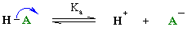

(1)
The addition of small amounts of acid or base to the buffer, or their generation or removal during the reactions being studied, either suppress this ionization (by mass action), or induces it, according to whether the level of acid or base is altered. For example, if H⁺ is used in the reaction, [H⁺] tends to fall but this causes dissociation of more HA to yield more H⁺ ions to compensate for the reaction.

The concentration of hydrogen ions in an aqueous solution is usually expressed in terms of the negative logarithm (base 10) of its actual concentration and denoted as pH.

pH= - log[H⁺]

(2)

The ability of the buffer to resist a pH change is defined as its capacity (or buffer value):
Capacity =
Where ∆pH is the change in pH produced by an equivalent (∆n) in the amount of H⁺ or OH⁻ added. It depends on the volume used and the concentrations of the two buffer components (Why?).

A buffer can be prepared in either of two ways:

- Known amount of HA and A⁻ forms (e.g. free acid and a salt of the acid) may be added to water and diluted to the required volume.
- A known amount of the acid is dissolved in water and a known amount of base is added and the mixture diluted to volume.
The molarity of a buffer refers to the total concentration of the buffering species [HA]+[A⁻]. For example an 0.5 M H₂PO₄/HPO₄⁻ buffer is one which the total concentration of phosphate is 0.5 M.

The equilibrium constant for equation (1) is given by

K_{eq} =

Where the brackets refer to molar concentrations.

By taking logarithms and rearranging we get

-log [H] = - log K_{eq} + log
Or
pH = pK_{a} = log
This is called the Henderson –Hasselbalch equation.

From equation 2 we see that pH = pK when [HA] = [A⁻] hence the reason for defining pK = -log(K)
Neutrality is when pH=7 on the scale 0-14, the solution being acid if the pH is below this value and alkaline if above. In pure water the concentrations of H⁺ and OH⁻ are identical and the product (the ion product for water) is K_{w}.
K_{w} = [H⁺] [OH] = 10 ⁻¹⁴ (at 25°C)
Or
pH + pOH = 14
at pH 7, pOH = 7

∴ the concentrations are equal.

Notes re Henderson – Hasselbalch equation

- Strictly the equation should involve thermodynamic activities and not molar concentrations. For dilute solutions the difference may be ignored (the unknown activity coefficients can be assumed to be unity).
- The dissociations are defined in terms of the loss of protons

(H₂CO₃ HCO₃⁻ + H⁺; NH₃ + H⁺)
And hence K is an acid dissociation constant. There are thus three possibilities
- dissociation involves a charge change neutral → negative entity
- highly positively charged entity to one with lower positive charge
- negative entity to one having higher negativity.

- If the molecule has more than one ionisable group then pK values are numbered in order of ionising pH.
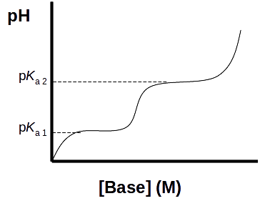

Note that the slope of the curve is least at the pK_{a} so that the buffering capacity is then greatest. In other words, a buffer component must be chosen which has a pK_{a} close to the pH required. It is of little use choosing a buffer which has a pK_{a} differing from the pH required by more than one unit.
A buffer operates in a specific pH range, which is around the pK_{a} value of the weak acid.

NOTE: the range pK_{a} ± 1 involves a hydrogen ion concentration change of 100 fold!
The ability of a buffer to resist a change in pH is defined as its capacity. The buffering capacity of a solution is tested by adding small amounts of acid, (e.g. HCl) and base, (e.g. NaOH) and checking the pH after each addition. If the pH changes only slightly, the solution is a good buffer.

- The ratio of the concentrations of ionised and un-ionised components can be determined from the pH and pK_{a} values. From the equation 2 we see that at pH = pK_{a} -1, 91% of the component is in the unionised form while at pH = pK + 1, 91% is in the ionised form. At two units above or below the pK_{a,} these values becomes 99%.

Titration Curves:

A titration curve is a graph depicting the pH of a solution as a function of the equivalents of acid or alkali added to the substance being titrated. Experimentally this may be done in a number of ways, e.g.

substance in acid solution titrate with alkali alkaline end point

substance in alkaline solution titrate with acid acid end point

titrate titrate
acid end point with acid substance in with alkali alkaline end point
water (neutral)

A plot of the pH against the amount of alkali added reveals the pKa of the weak acid. The most important point about the titration curve of a weak acid is that it shows graphically that a weak acid and its anion – a conjugate acid-base pair – can act as a buffer. The midpoint of a buffering region should coincide with the point at which half the equivalents of alkali have been added. This is the point at which the group is half dissociated, i.e. the pK_{a}. The pK_{a} (-log K_{a}) may therefore be defined as that pH at which the acid is half dissociated.

Consider the titration curves shown below: Which of the two solutions would you consider to be a good buffer? Justify your answer.

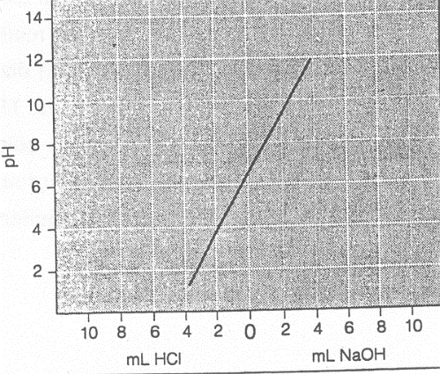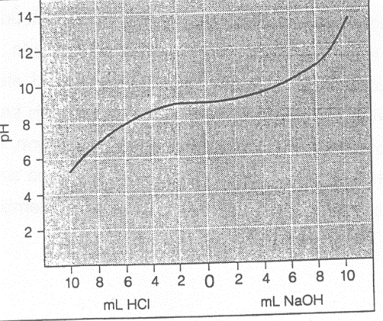

Solution A Solution B

Measurement of pH

There are several ways of determining the pH of an aqueous solution. The method of choice depends on the circumstances and the degree of accuracy required. This practical is concerned primarily with such measurement. The normal method is by means of a pH meter which is an instrument designed to measure the electrical potential between two electrodes immersed in the buffer. The reference, or fixed potential electrode, consists of a platinum wire immersed in a paste of mercury and mercuric chloride (hence named a calomel electrode), in contact with a saturated solution of potassium chloride which, in turn is separated from the test or standard solution by a porous plug. The second electrode consists of a silver wire coated with silver chloride immersed in the 0.1 M HC1. The latter is separated from the test solution by a special thin and fragile (treat with great care) glass membrane which is permeable develops across the membrane which is dependent on the hydrogen ion concentration difference between the buffer solution and the internal acid. The value is given by the Nernst equation.

Where
R is the gas constant (1.98 cal. deg. ⁻¹ mole ⁻¹)
T is the absolute temperature (°C)
F is the Faraday (23 000 Cal/volt)
The overall potential can be expressed as:
E = E_{o} – K . pH
Where E_{o} is the combined potentials of the other junctions. Hence, E is linearly related to the pH of its test solution.
Notes

- Because the concentration of protons inside the glass electrode generally varies with time and can depend on the treatment of the electrode before the measurement is made, the instrument should first be calibrated using standard buffers of known pH, one above that to be measured, the other below. The adjustment procedure depends on the instrument: familiarise yourself with the instructions of the instrument to be used.
- The constant, K, is temperature dependent and adjustment should be made for this especially if it is far from 25°C. For precise work it may be necessary to calibrate the electrode using standard buffers at the required temperature. Read the pertinent instructions carefully. The temperature coefficient ( ) depends on the buffer ions used (phosphate = -0.0003 pH units/°C); Tris is much higher, -0.028 pH units/ºC. Note that the pH should be measured at the temperature of use otherwise considerable deviations can occur particularly with Tris buffers.
- If the calomel electrode is not combined with the glass electrode it will probably not be sealed. In this case it is necessary to check (a) that it contains sufficient KCl solution to immerse the wire electrode and (b) that it is saturated with KCl. There should be crystals of the latter present. It is not sufficient to make fresh KCl solution at the time as the solution will not be completely saturated until it has been in contact with solid KCl for some hours.
- In addition to taking care with the sensitive glass electrode, neither that nor the porous plug for the calomel electrode should be touched or allowed to dry out. New glass (and combined electrodes should generally be immersed in 0.1 M HCl for some hours before use (see makers instructions). At other times they must be kept wet with standard buffer. If it is necessary to store an electrode it should be washed with distilled water before drying and its porous plug/glass bulb protected. Do not tape over either the plug or glass membrane. Most problems, such as drift, are usually due to blocking of the plug or the drying out of the glass bulb. There must be a very small but finite leakage through the porous plug. If stored dry, the glass electrode must be soaked again in 0.1 M HCl.
- Electrodes should be washed with distilled water prior to each measurement and the last drop of water remaining (after draining) should be removed by touching with a tissue or a piece of filter paper. Wiping with tissue can give rise to static charge and unreliable results.

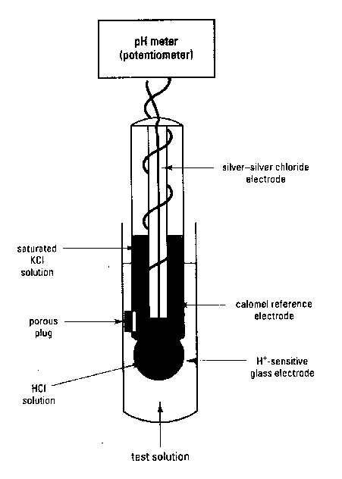

Fig 1. Combination pH electrode. The electrical potential difference recorded by the pH meter is directly proportional to the pH of the test solution. (Reed et al. 2003)

INDICATORS

It is also possible to estimate roughly the pH of a solution by means of soluble indicator dyes (or indicator papers impregnated with such dyes) which change colour as their ionization state change (remember Litmus). Bromothymol blue, (pK_{a} of 7.1) for example, is yellow in acid and blue in alkaline solution. At a pH = pK_{a} it is green since it contains equal number of molecules of ionised and unionised forms. Note that when examined by eye, one can only tell if the pH is near or well above or well below the pK_{a} value but spectrophotometric observation can provide more accurate pH value when the latter is near the pK_{a} (Why only then?). Visual assessment of pH requires at least 10% of one form or the other of the indicator to be present but the composition and concentration of materials in the test solution (e.g. the total indicator concentration, carbon dioxide, salt concentration, presence of protein, temperature) may also influence the forms present. Some dyes bind to protein and change colour: this effect has been used to devise a colorimetric method of determining the protein concentration. For reasonable comparisons the amount of indicator in different solutions must be essentially the same.
PHYSIOLOGICAL BUFFERS

The main components acting as buffers in blood and cells are carbonic acid, bicarbonate, phosphates and proteins. Note: unless freshly distilled or deionised water is used, water is likely to contain variable amounts of CO₂. Ideally, one should store distilled water in a vessel filled with a CO₂ trap (containing lime) – or the water should be boiled before use (CO₂ might react with components of interest).

An ideal buffer for biological purposes would possess the following characteristics:
- possess biological stability and not interfere with metabolic processes:
- be impermeable to biological membranes
- lack significant absorption of UV or visible light
- not form insoluble complexes with cations
- have a minimal effect on ionic composition or salt concentration
- pH change in response to temperature change should be minimal.

Citric acid and phosphate buffers form insoluble complexes with divalent cations. Phosphate can also act as a substrate, inhibitor, or activator of certain enzymes. TRIS is often toxic to biological systems because it can penetrate membranes. (It is highly soluble in lipids). A number of zwitterionic molecules (possessing both positive and negative groups), have been introduced to overcome some of the disadvantages of the more traditional buffers. An example of this type of buffer is HEPES.

CALCULATION OF pH

The Henderson-Hasselbalch equation defines the pH as a function of the ratio of the ionised and unionised buffer compound. In order to express the pH in terms of the concentration of the buffering agent used:
- It is necessary to use conservation equations of the kind
[Acid] = [Ac⁻] + [HAc]
Where [Acid] is the total concentration (molarity) of the acid used, and
- The conditions for electrical neutrality. The concentration of negative ions must equal that for positive ions, e.g.
[H⁺] = [Ac-] + [OH⁻]
Except for very dilute solution of buffers it is often possible to simplify the resultant equations. For example in the neutrality equation we may neglect [OH-] in relation to [Ac⁻] particularly since the added [H⁺] from the acid depressed the dissociation of water.
On this basis the following approximations can be deduced.
  - For a salt of a strong acid and weak base

  - Salt of a strong base and weak acid

  - Salt of a weak acid and weak base

  - Solution of weak acid

  - Solution of a weak base

where
[S] = molar concentration of the salt
pK_{w} = -log(ion product of water) = -log K_{w} = 14 (at 25°C)
pK_{a} = acid pK of the weak acid and/or the weak base

As an exercise you should attempt to derive these equations from the Henderson-Hasselbalch equation, the conservation equation and on the basis of electrical neutrality (distinguish the latter from neutrality used in relation to pH).

METHODS:

The pH meter

Familiarise yourself with the operation of the pH meter. Always remember to handle the electrodes with care. Do not leave the electrodes out of solution for more than a few minutes at a time. When changing from one solution to another, rinse the electrodes with distilled water and remove any drops of water by touching gently with tissue paper.

The pH meter cannot be calibrated for the entire pH range. Therefore it must be set for the range that you will be using, i.e. either in the 4 – 7 range or the 7 – 9 range. Please do not contaminate the buffers, and please remember to return them to the correct stock bottles.

A) Procedure for Obtaining a Titration Curve for Acetic Acid:

Set up a burette containing 1.0 M NaOH.
Measure 50 ml of 0.1 M acetic acid into a clean 100 ml beaker. Immerse the electrodes in the solution, and measure the pH. Add 0.5 ml of 1 M NaOH from the burette. Mix the solution by GENTLE rotation and take a reading. DO NOT USE THE ELECTRODES FOR STIRRING. Continue adding 0.5 ml increments from the burette. Remember to mix well and record the pH after each addition of alkali. Record your results in a table i.e. Volume of NaOH added vs. pH recorded. Calculate the number of equivalents of NaOH added after each addition.

Plot the titration curve for 0.1 M acetic acid. Estimate the pKa of acetic acid from the titration curve and on your graph indicate the buffering range (See report section question 6).

B) Preparation of Acetate Buffer and Estimation of Buffering Capacity:

1. Prepare 120 ml of 0.2 M sodium acetate (Mr = 82 g.mol-1). (Use a volumetric flask to make up to volume with distilled water ).

- Prepare a 0.2 M solution of glacial acetic acid (100%; Mr = 60.05 g.mol-1; density = 1.05 g/ml) in a 120 ml volumetric flask, using a safety pipette. (Caution: glacial acetic acid causes severe burns.)

- Use the Henderson-Hasselbalch equation to calculate the volumes of each solution required to make up 50 ml of a 0.2 M acetate buffer, pH 4.4. The pKa of acetic acid is 4.76.

- Combine the appropriate volumes of each solution (as calculated in 3) and measure the pH.

- Take 25 ml of your acetate buffer and dilute it 4 times. Measure the pH. Does ionic strength affect the pH?

- Accurately measure (and record) any volume (between 5 ml and 40 ml) of 0.2 M sodium acetate solution. Add 0.2 M glacial acetic acid solution to make up 50 ml of acetate buffer. Use the Henderson-Hasselbalch equation to calculate the pH of the buffer you have made up. Confirm your calculations by measuring the pH using a pH meter.

- Using the buffers you made in 4, 5 and 6 above, devise (and perform one aspect of) an experiment that would test which factors affect the buffering capacities of the acetate buffers. In addition to the acetate buffers you made, you will be provided with distilled water (think why), and with 0.1 M HCl and 0.1 M NaOH.
PRACTICAL: REACTIONS OF ALDEHYDES AND KETONES

INTRODUCTION

The carbon-oxygen double bond is one of the most important functional groups in both organic chemistry and biochemistry. Many important biochemistry processes involve reaction at a carbonyl centre.
Reactivity of the carbonyl group is governed by the electron imbalance in the π orbitals of the bond between carbon and a more electro-negative atom.
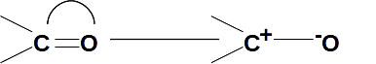

Consequently the carbon atom will be susceptible to nucleophilic attack, and particularly so if the oxygen is protonated, although strongly acidic conditions may adversely affect the nucleophile.

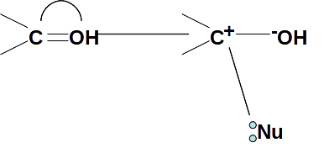

If the carbonyl group has hydrogens in the α position, it can tautomerise to the enol form:
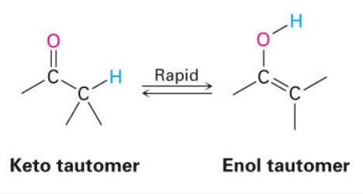

Carbonyl groups having one alkyl substituent and one hydrogen are known as aldehydes and those having two alkyl substituents are known as ketones. Both aldehydes and ketones undergo reactions characteristic of the carbonyl group but aldehydes can be distinguished from ketones because of their susceptibility to oxidation.

NOTES
- Derivatives
In order to identify an organic compound it must be shown to have exactly the same physical and chemical properties as a known compound. Although comparison by the mixed melting point method is usually satisfactory it is better (and essential in the case of liquids) to prepare solid derivatives of the unknown and known specimens and compare the properties of those as well. A derivative is the product formed when a compound is subjected to a known chemical reaction under known conditions, and is a useful means of comparing two samples. Ideally a derivative should be:

- Easily and quickly prepared in high yield,
- A solid with a sharp melting point,
- The product of a general reaction which under the same experimental conditions would yield a derivative with other compounds belonging to the same class,
- Markedly different from the original compound in physical properties.

MATERIALS AND METHODS

You are provided with a range of samples and two unknowns
Chromic anhydride reagent, Tollen’s reagent and iodine-potassium reagent have been provided for you and you do not need to make the reagents yourselves.

1. Brady’s Test (not to be performed in this practical)

2,4-Dinitrophenylhydrazine (Brady’s reagent) can be used to test whether a substance is an aldehyde or ketone. The reaction is a nucleophilic addition reaction followed by the elimination of water as shown by the following scheme:

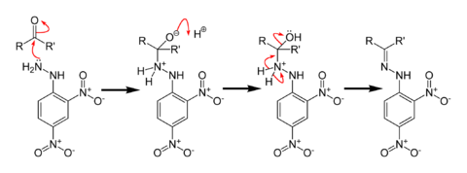
A positive test is the presence of 2,4-Dinitrophenylhydrazone- a yellow/red precipitate

- Chromic Anhydride (Jones’s Test)

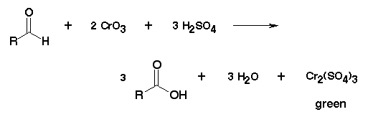

- Use all samples unknowns. Add one drop of carbonyl compound to 1 ml of acetone in a test tube, mix and add one drop of the chromic anhydride reagent. (Dissolve 23,5 g Chromium Trioxide in 21 ml concentrated H₂SO₄ with cooling and dilute with distilled water to give a final volume of 175 ml.) Observe any changes. Does this test distinguish aldehydes from ketones?
- Repeat the test with butanol, sec-butanol and tertiary butanol.
- Give a full explanation of your observations in your discussion.

- Tollen’s Reagant

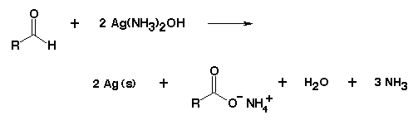

- Add two drops of 10% sodium hydroxide to 10 ml of 0.3 M aqueous silver nitrate and mix well. Add slowly with shaking a dilute solution of ammonia until the precipitate just dissolves. Avoid an excess of the ammonia. This is Tollen’s reagent.

- Use all samples and unknowns. Add 1 drop of carbonyl compound to 1 ml of Tollen’s reagent in a test tube, shake, and set aside for 10 mins. A positive test is the formation of a silver mirror on the tube, or a black precipitate of silver. If the test is negative, heat for 5 mins in a boiling water bath and reassess.

(NB: Tollen’s reagent deposits an explosive precipitate on standing even for a few hours. Make sure you wash the excess reagent down the sink immediately after you have performed all the tests).

- Iodoform reaction

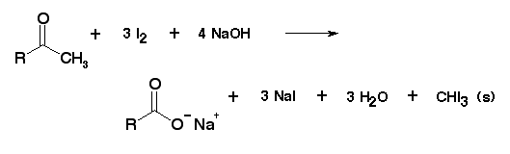

- Perform this test with acetone, cyclohexanone, acetaldehyde, ethanol, methanol and isopropanol.

- Add 3 drops of sample to 1 ml of water. Add 3 ml of 10% sodium hydroxide solution (use pipette filler to dispense) and then add dropwise the iodine-potassium reagent (10g iodine in 12% potassium iodide) until the faint colour of iodine persists. If there is no precipitate after 2-3 minutes warm the tube at 60°C for 5 minutes. Add more iodine reagent if the faint colour disappears, continue the addition until the colour persists for 2 minutes. Remove the excess iodine by adding sodium hydroxide solution dropwise and shaking. Dilute with an equal volume of water and allow to stand for 10 minutes. The test is positive only if a yellow precipitate appears.

DISCUSSION AND CONCLUSION

Attempt to rationalise all the experiments you have performed in terms of the reactivity of the carbonyl group. Account for any positive reactions given by non-carbonyl compounds. Give all relevant chemical equations, properly balanced.

EXERCISES

- In the formation of semicarbazones, sodium acetate is added to maintain a pH of 4-5
Explain fully why this is necessary.
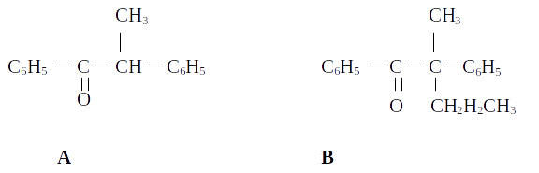
- Why does the optically active ketone A undergo racemisation in bases solution, whereas the optically active ketone B does not?

PRACTICAL: COLORIMETRIC ASSAY OF NITRITE IN PROCESSED MEATS

Introduction
Processed meat such as ham, salami and Vienna sausages are treated with sodium nitrite which is used as an antimicrobial agent against potentially harmful bacteria contamination of processed meats. Treatment of the processed meats with sodium nitrite also gives the meat their pink coloration. It is well established that ingestion of nitrite which is toxic can cause damage to cells and can also cause cancer when nitrite as a substrate becomes chemically integrated into various organic compounds in the body resulting in the formation of carcinogens.

Nitrite formation in nature and its assay
Nitrate is reduced to nitrite by reduced nicotinamide adenine dinucleotide phosphate (NADPH) in the presence of the enzyme nitrate reductase (NR). (1) Nitrate + NADPH +H+ NR → Nitrite + NADP+ + H20. In the colorimetric assay nitrite reacts with sulfanilamide and N-(1-naphthyl)-ethylene-diamine dihydrochloride to give a red-violet diazo dye. (2) Nitrite + sulfanilamide + N-(1-naphthyl)- ethylenediamine → diazo dye. The diazo dye is measured on the basis of its absorbance in the visible light range at 540 nm.

Extraction of nitrite from processed meats
Chop a Vienna sausage into small slices and briefly boil in 100 ml distilled water in an Erlenmeyer flask. Afterwards filter the solution by pouring through a glass funnel lined with a cone of Whatman No 1 filter paper (90 mm disc) and collecting the filtrate into a clean 100 ml Erlenmeyer flask.

Preparation of standard nitrite solutions.
To prepared sodium nitrite-standard solutions, accurately weigh out 75.0 mg (± 0.1 mg) sodium nitrite into a 100 ml volumetric flask, dissolve in redistilled water and make up to the mark with the same solvent (stock solution = 500 mg nitrite/l). Prepare a nitrite calibration curve by diluting the stock solution with redistilled water to give concentrations in the range from 5.00 mg and 0.05 mg nitrite/l.

Colorimetric reagents
Sulphanilamide:
Dissolve five grams of sulphanilamide in 500 ml 1.2 N hydrochloric acid. Store solution in stoppered amber glass bottle.

N-(1-naphthyl)- ethylenediamine:
Dissolve 0.5 gram of N-(1-naphtyl)-ethylenediamine in 500 ml of distilled water. Store solution in stoppered amber glass bottle out of direct sunlight.

Nitrite calibration curve
Mix 1 ml of nitrite stock concentrations with 1 ml sulphanilamide and 1 ml of N-(1-naphtyl)-ethylenediamine in a 10 ml glass test tube. Zero the spectrophotometer using a blank solution. Using a spectrophotometer measure absorbance at 540 nm after pouring the mixture into a cuvette.

Vienna sausage nitrite assay
Add 1 ml of filtered Vienna sausage solution to 1 ml sulphanilamide and 1 ml of N-(1-naphtyl)-ethylenediamine into a 10 ml glass test tube. Measure absorbance at 540 nm. The colour is too dark make a 1 in 10 dilution in distilled water of the Vienna sausage solution and repeat the above exercise. From the standard curved determine the concentration of nitrite in the Vienna solution. Using this data calculate the amount of nitrite in one Vienna sausage.

Plot calibration curve
On graph paper plot the calibration with absorbance (y axis) versus nitrite concentration (x axis) in mg/l.

Laboratory Report
Write a short laboratory report in the standard scientific paper format: Title, Abstract, Introduction, Materials and Methods, Results and Discussion, Conclusions and References.

PRACTICAL: ESTIMATING THE SUGAR CONCENTRATION IN COCA-COLA

Introduction
As a general rule, it is thought there is about 10.6 g of sugar per 100 ml of Coca-Cola Classic. This is roughly equivalent to two heaped teaspoons of sugar.

Sucrose standards
Weight out 20 g sucrose in 1 L distilled water and make up a series of dilutions (1, 1 in 10, 1 in 50, 1 in 100, 1 in 250, 1 in 500 and 1 in 1000) for the calibration curve.

Test solution
In 10 ml glass test tubes make a series of dilutions (1 in 10, 1 in 50, 1 in 100 and 1 in 500) of Coca-Cola in distilled water.

Colorimetric reagents
The two reagents for the colorimetric determination of sucrose concentrations in solutions consists of 0.1% (w/v) resorcinol in 95% ethanol and 30% HCl.

Sucrose assay
Add 0.25 ml of 0.1% (w/v) resorcinol in 95% ethanol and 0.75 ml of 30% HCI to 1.0 ml of sucrose solution in a 10 ml glass test tube. Incubate the mixture at 80 °C in a water bath for 8 minutes. Allow the tubes cool to room temperature and then, using the cuvettes provided measure absorbance using a spectrophotometer, set at a wavelength of 520 nm. First zero the spectrophotometer with the blank. Do the colorimetric assay for each of the standard solutions and for the test solutions prepared from the Coca-Cola.

Plot standard curve
On graph paper, plot Absorbance versus Sucrose concentration and determine: 1) the sucrose concentration in the test solutions and 2) the total amount of sucrose in one can of Coca-Cola. Determine the concentration of sucrose in a can of coke.

Laboratory Report
Write a short laboratory report in the standard scientific paper format: Title, Abstract, Introduction, Materials and Methods, Results and Discussion, Conclusions and References.

PRACTICAL: SEPARATION OF NATIVE PROTEINS BY AGAROSE GEL ELECTROPHORESIS

References:
Farrell and Ranallo (2000). Experiments in Biochemistry, A hands-on Approach, Thomson learning Inc.
Reed et al (2013) Practical skills in Biomolecular sciences 4th ed, Prentice Hall

OBJECTIVES
At end of the practical students should be able to:
- Pour and load an agarose gel.
- Calculate amount of agarose and buffer for making gel.
- Explain and apply the principles of gel electrophoresis.
- Distinguish between different proteins, based on their electrophoretic properties.
- Explain and discuss how proteins can be separated and identified based on their electrophoretic properties.

Background
Electrophoresis is the technique where charged molecules are separated based on their migration in an electric field, often supported by a matrix such as agarose or polyacrylamide. It is widely used technique for analysis of purity and identification of isolated biomolecules such as proteins and nucleic acids.
The rate at which charged molecules migrate depends on net charge, size, shape and electrical strength according to the following equation:

A charged molecule will move towards opposite charge in the electric field i.e. the negatively charged molecules (anions) migrate towards the anode (+), while positively charged molecules migrate towards the cathode (-). In addition, highly charged molecules move faster towards the electrode of opposite charge than those less charged i.e. a molecule with a charge of -2 will move twice as fast as a molecule with a charge of -1 under similar conditions. Remember, the net charge of biological molecules such as proteins depends on the pH of the medium they are in. Changing the pH of the buffer in the system will change the net charge of some molecules. According to above formula, increasing the voltage, E, should speed up the separation, however, there are practical limitations to using high voltages, especially heating effects that could destroy the sample or support medium. Thus for cleaner and sharper bands, gels are preferably run slowly.

The frictional coefficient depends on size and shape of molecule and nature of support medium. For example, a round protein will move faster than rod-shaped protein of equal weight. A denser medium will retard larger molecules while smaller molecules will move faster than larger one under similar conditions.

Proteins are composed of different amino acids chains which give a protein its unique size and shape. The charge of the protein depends on both the amino acid composition and the pH of the medium. The protein that is made up of many glutamic acid and aspartic acid residues will have a negative charge at physiological pH. While the protein‘s positive charge at physiological pH depends on amino acid carrying a basic group namely lysine and arginine and to a less extent histidine. The side chain on histidine can exist as either a positively charged form or as uncharged hence acts as a buffer under physiological pH. Depending on the pH of the medium they are dissolved in, proteins contain both positive and negatively charged groups and are known as amphoteric. At the isoelectric point (pI), the positive and negative charges are equal in number and the ampholyte will not migrate in electrical field. Proteins that contain more glutamic acid residues and aspartic residues will have their isoelectric points at acidic pH values while lysine-rich and arginine-rich proteins will have isoelectric point at alkaline pH values.

The proteins exhibit many different three-dimensional shapes and complex structures that depends on their amino acid composition and attached “non-amino acid” group collectively called prosthetic groups that are added after post-translational processing. The Prosthetic groups such as the haem (iron complexed to a system of organic rings called porphyrin) of haemoglobin and cytochrome C enable proteins to carry their biological functions and influence the protein’s chemical properties. In general, the protein shape ranges from spherical, elliptical or rod-like and the molecular weight depends on the number of peptide, nature and number of amino acids, and attached non-amino acid groups making up a protein. Thus, the rate at which the proteins can be separated on the agarose gel depends on their size, shape and charge. After electrophoresis, the protein molecules in the gel can be located by a specific or general protein stain. Identical molecules will move at the same rate through the gel so that a sample of purified gel will move as single band. Thus, electrophoresis is one of the valuable tools for establishing how many molecular species a given protein may have.

Proteins that are in their normal biological active forms are called native, i.e. proteins are not denatured or their specific 3-D folding and biological activity are not lost. Certain detergents, extreme pH, organic solvents and heat can denature proteins and alter the behaviour of the protein. Thus denatured proteins may have different electrophoretic properties compared with their corresponding native counterparts.

In this practical, agarose gel electrophoresis will be used to separate native proteins. Agarose is a solid support and a natural polysaccharide of galactose and 3, 6-anhydrous galactose derived from red algae. Agarose gels are native gels in which molecules retain their native conformation and activity. However, note that high temperature may denature the proteins and destroy their biological activity. Agarose gels are made in a buffer NEVER in water at 0.7 - 2% (w/v). Resolution of proteins in agarose gels does not give sharp bands as with polyacrylamide gels. Polyacrylamide is another solid support that has microscopic pores of defined size and range that act as molecular sieve. Unlike, agarose gels, polyacrylamide gels can involve use of detergents such as sodium dodecyl sulfate (SDS) that may denature proteins thus not ideal for studying electrophoretic properties of native proteins.

Electrophoresis of native proteins is important in clinical analysis of complex samples such as serum, which is composed of many proteins of different mass, shape, size and charge. Electrophoresis of serum at alkaline pH results in separation of the components of the serum. Albumin is the most abundant and one of the fastest proteins to be separated from serum while γ-globulins are the slowest.

In this practical, you will assess the migration patterns of bovine serum albumin (BSA), ovalbumin, cytochrome C, lysozyme and Horse Serum peptides.
Protein | Molecular Weight (Dalton) | Isoelectric point (pI)
Bovine serum albumin (BSA) | 68000 | 4.7
Ovalbumin | 43000 | 4.6
Cytochrome C | 12000 | 10.7
Lysozyme | 140000 | 11.2
Horse Serum peptides

Methods
Agarose gel will be partially prepared for students and kept in 50 ⁰C water bath until use
  - Prepare 60 mL of 0.8% w/v reservoir buffer
  - Weigh 0.48 g agarose powder on a scale
  - Mix the agarose powder into the 60 mL reservoir buffer
- Heat in the microwave until the agarose has melted (30 - 40 s at high power per flask). Swirl to mix.
- Leave the solution in a 50 - 60 ⁰C water bath to cool.

STUDENTS START HERE

Pouring Agarose
- Assemble the gel casting apparatus (TA will have demonstrated this). Place a piece of paper towel underneath in case of leaks.
- Place the comb in the middle of the gel, such that it divides the gel casting tray into almost equal sections. (TA will have demonstrated this)
- Remove a bottle of liquid gel mixture from the 50 - 60 ⁰C water bath.
CAUTION: THE BOTTLE IS HOT. WEAR GLOVES AND HANDLE WITH CARE!
- Check that the solution is clear with no agarose clumps (ask TA if in doubt).
- Pour 60 mL gel into gel casting tray.
- Allow the liquid to set (15 - 20 minutes).

Sample preparation and application
- While the gel is setting,
  - Each group will be given one sample (20 µl) of either sample A, B, C, D or E. Centrifuge the tubes for a couple of seconds in centrifuge to bring entire sample back down (only if necessary).

- Place the gel casting tray in the electrophoresis tank (TA will demonstrate).
- Remove the comb without tearing the wells.
- Make sure you note which side of agarose gel is nearer to the black (negative) electrode and which one is nearer to the red (positive) electrode.
- Slowly fill the chamber with electrophoresis (reservoir) buffer until the level of the buffer is about 1 cm over the gel.
- Using pipette, load your sample (More instructions will be given). Make sure each well is not overflowing
- Put on the lid and connect the leads to the power supply. Make sure you have connected the electrodes correctly to power supply, i.e. “Black to black” and “red to red”. (Check with TA if in doubt).
- Set the power source at 100 volts until marker bromophenol blue dye is close to running off the end (1 - 3 hours). To check that current is flowing, you should see bubbles forming at electrodes.
- After electrophoresis is complete, turn off the power supply, remove the lid and take the gel for staining.
Note: One gel will be run early so that the following steps can be performed together in case we run out of time.
Staining
- Using the small plastic boxes provided, slide the gel out of the casting tray (TA will show you how to do this).
- Cover the gel with about 100 mL of Fixative solution: 25% Isopropanol, 10% acetic acid. Leave the gel to soak for 30 minutes. Pour the Fixative back into bottle when you are finished.

Note: Isopropanol is flammable. Avoid contact with strong acids and alkalis, heat and strong oxidisers. Lab coats, gloves and chemical splash goggles should be worn when handling Isopropanol.
- After pouring out the Fixative, cover the gel with about 100 mL staining solution (10% acetic acid in Coomassie Blue water (60 mg/L)). Allow to stain with gentle agitation on rocking platform for 30 minutes. Pour the Staining solution back into the bottle when finished.
- After pouring out the Staining solution, cover the gel with about 100 mL De-Staining solution (10% acetic acid in water).
- Leave gel to soak in De-Staining solution for as long as is required. Pour the De-Staining solution back into the bottle when finished.
- The protein bands will appear as dark blue bands against the light background.
- Photograph or Sketch the gel.

PRACTICAL REPORT: SEPARATION OF NATIVE PROTEINS BY AGAROSE GEL ELECTROPHORESIS
MCBG 2036
Prof M Kaur

Person Number_______________ Date_________________ Marks: 20

Instructions:
You may discuss your answers with your group members and check with the TA if in doubt. Hand in the practical report to your TA at the end of the practical session or next day. Answer all questions

- Define the following in terms of charge: (0.5 mark each, total 2 Marks)
Cathode...................................................................................................................................
Cation......................................................................................................................................
Anode......................................................................................................................................
Anion.......................................................................................................................................
- At pH 7.8, which of the following proteins (BSA, Ovalbumin, Cytochrome C, Lysozyme) have net positive charge? Which have net negative charge? (2 marks)
.....................................................................................................................................
.....................................................................................................................................
.....................................................................................................................................
.....................................................................................................................................
- You want to prepare 50 mL of 1.5% (w/v) agarose gel in 1 x Tris-Borate EDTA (TBE) buffer.
- How much agarose will you weigh? (1 mark)

- What is the volume of water and Tris buffer that you will need to make 1x Tris Borate EDTA (TBE) buffer from following stocks?

  - 50xTBE stocks (2 marks)

  - 10xTBE stocks (2 marks)

- Using the equation describe the effects of the following on the way the gel would run.

- Decreasing the voltage. (1 mark)
.....................................................................................................................................
.....................................................................................................................................
.....................................................................................................................................
- Increasing agarose concentration to 1.5%. (1 Mark)
.....................................................................................................................................
.....................................................................................................................................
.....................................................................................................................................
- Before loading your protein samples, they were mixed with glycerol and bromophenol blue tracking dye (sample buffer). Does the tracking dye migrate faster or slower than proteins? During electrophoresis of serum proteins, the bromophenol blue may separate into two bands. Why is this? (3 marks)
.........................................................................................................................................
.....................................................................................................................................
.....................................................................................................................................
.....................................................................................................................................
.....................................................................................................................................

- Sketch your gel picture. Use the following information to identify your samples. Explain your results, assume all these proteins are spherical; therefore, increasing molecular weight corresponds to increasing size. (4 marks)

-ve
Lane 1: Cytochrome C
Lane 2: Ovalbumin
Lane 3: Bovine Serum Albumin (BSA)
Lane 4: Lysozyme
Lane 5: Horse Serum proteins

+ve

- Based on your observations, would you expect ovalbumin to have more or less lysine and arginine residues than lysozymes? Why? (2 Marks)
.....................................................................................................................................
.....................................................................................................................................
.....................................................................................................................................

PRACTICAL: SEPARATION OF HAEMOGLOBIN AND VITAMIN B12 USING GEL FILTRATION CHROMATOGRAPHY

References: Wilson and Walker (2005). Principles and Techniques of Practical Biochemistry, 6e, Cambridge University Press.
Reed et al., (2013). Practical Skills in Biomolecular Sciences, 4e, Prentice Hall.
Boyer, R (2006) Biochemistry Laboratory - Modern theory and Techniques, Benjamin Cummings, San Francisco.

OBJECTIVES:
At the end of this practical students should be able to:
1. Explain the theoretical basis of protein purification. (Refer to textbooks)
2. Complete a purification table.
3. Explain and apply the principles of gel filtration (size exclusion) chromatography.
4. Determine the optimum absorbance maximum wavelength for haemoglobin

THEORY:

All protein purification techniques are based on exploiting the properties by which proteins differ from one another. These properties include: differences in heat sensitivity, solubility, net charge, size etc. The protein that you wish to purify will be one of many other proteins and molecules in a cell, and may constitute as little as 0.001% of the total protein in the cell. Purification involves a number of steps and utilizes different techniques. During a purification procedure, one needs to keep track of several parameters including:

- The total volume of the sample
- The total amount of protein in the sample
- The total amount of the protein of interest (the one you are trying to purify)

This basic information is necessary in order to keep track of the following parameters during each step of the purification:

- % yield for each purification step
- specific activity of the desired protein (i.e. "units" of activity of the desired protein/total protein)
- fold purification (i.e. the purification enhancement)

Information about the yield and purity of the protein is recorded in a purification table similar to the one shown below. A purification table allows a researcher to evaluate easily each procedure in order to assess whether the step has been effective or ineffective.

The various parameters are calculated as follows:
- Total activity: This is a measure of the total units of protein present in a sample.
- Specific activity: This is the amount of measured protein of interest (the one that you are purifying) there is with all the other contaminating proteins. Divide the activity (for an enzyme) by the mg of protein. The higher this value the greater the purification.
- Fold purification (purification factor): Divide the specific activity of each fraction by the specific activity found in the initial fraction.
- Yield: This is calculated by dividing the total activity for each step by that of the starting step and presenting it as a percentage.

Example Purification Table

Purification step | Total protein (mg) | Total activity (µmol/min) | Specific activity (µmol/min/mg) | Yield (%) | Purification fold
Cell extract | 375.28 | 127.36 | 0.34 | 100 | 1
Ammonium sulfate | 38.19 | 101.19 | 2.65 | 79 | 8
Gel Chromatography | 2.95 | 43.30 | 14.68 | 34 | 43
Affinity chromatography | 1.00 | 26.15 | 26.15 | 20 | 77

Chromatography

Chromatography is a procedure used to separate the individual constituents within a sample on the basis of differences in their physical characteristics. Chromatography separates complex mixtures of molecules based on the differential distribution of the molecules in the mixture between a mobile and a stationary phase.

In column chromatography, a column is packed with an appropriate stationary phase and the column is equilibrated by passing the mobile phase through the column, either by gravity, or by pumping it through with a low pressure peristaltic pump. The sample is introduced to the top of the column (taking care not to disturb the surface) to form a discrete band of material, and is then washed through the column by the mobile phase. It should be obvious that substances that interact strongly with the stationary phase will be retarded, or will move more slowly than substances that show little interaction with (or affinity for) the stationary phase. This will result in differences in their elution times from the column.
Gel Filtration chromatography (also called size exclusion / gel permeation chromatography)

Gel filtration chromatography separates molecules of different sizes. A protein can be separated from other molecules (including other proteins) that are present in the initial mixture on the basis of their different sizes. Gel filtration is therefore a useful technique to apply in protein purification. In Gel filtration chromatography, the column is packed with the stationary phase which is in the form of beads of a cross-linked gel containing pores of a discrete size. The size of the pores will allow the entry of small molecules into the gel beads while excluding large molecules. Molecules of intermediate size partially enter the pores. If a sample is placed at the top of this type of column, the mobile phase will carry the sample components down the column at different rates according to their molecular sizes. Selectivity is solely dependent on the gel used for the stationary phase. Large molecules will only have access to the volume of mobile phase surrounding the beads and so will elute with the “void volume” (v_{o}); small molecules will have access to the volume of mobile phase surrounding the beads as well as the volume occupying the space inside the beads and therefore they will have to pass through the total liquid volume of the column (v_{t}) before they emerge; intermediate molecules will elute (in order of decreasing size depending on their access to the gel) at a volume between v_{t} and v_{o}.

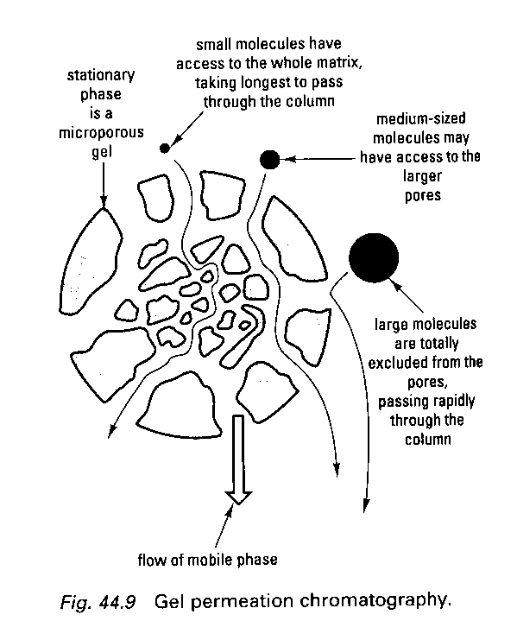
Fig 1: Principles of gel filtration chromatography

Applications of gel filtration chromatography are:
- To separate mixtures of molecules of different molecular weights
- To estimate the molecular mass of a sample component by calibrating a given column using molecules of known molecular mass and with similar shapes (v_{e} = the volume of eluent that leaves the column ahead of the peak of the fraction)
- To perform a general separation of low molecular mass and high molecular mass components,

Terminology used in Gel Filtration chromatography
- Elution volume (V_{e}): elution volume is measured from the chromatogram and is influenced by the size of the molecule
- Total volume (V_{t}): total column volume which is equivalent to the volume of the packed bed.
- Void volume (V_{o}): void volume is the elution volume of the molecules that are excluded from the beads in the column.
- Resolution: degree of separation between the peaks.

One of the objectives of this practical is to demonstrate the use of gel chromatography to separate haemoglobin from vitamin B12. These molecules are useful for a demonstration of the principles of column chromatography, and gel filtration in particular, as they are coloured so that you can see and monitor the events as they take place.

Haemoglobin
Haemoglobin is a protein found in red blood cells and functions to transport oxygen to the tissues. It is made up of four polypeptide chains, each of which contains an iron-containing haem molecule (shown below) which is responsible for the red-brown colour of the haemoglobin molecule. Haemoglobin has a molecular weight of 65 000 dalton.

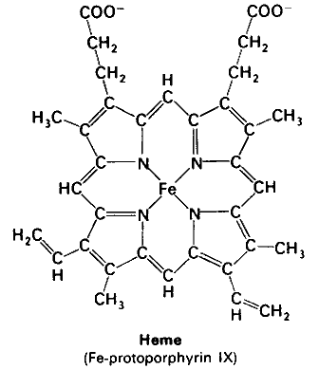

Vitamin B12
Vitamin B12 (cobalamin), which is shown below, is a pink molecule that has a molecular weight of 1350 dalton. Vitamin B12 is an essential cofactor of several biochemical reactions that occur in the human body. Haematological consequences of vitamin B12 (cobalamin) deficiency can be severe. Patients with vitamin B12 deficiency have been found to have haemolysis that has been attributed to concurrent destruction of red blood cells and ineffective erythropoiesis.
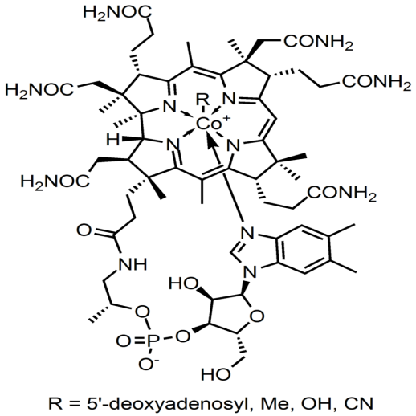
Determination of the absorbance spectrum of a molecule

The extent to which light is absorbed by a molecule depends on the wavelength of the light. For this reason, if you want to measure the absorbance of light by a molecule it is necessary to first determine the wavelength of maximum absorbance - or to determine the absorbance spectrum of the molecule. Therefore, once you have separated haemoglobin and vitamin B12, you will determine the absorbance spectrum of haemoglobin and use the λ_{max} to read the absorbance of all the fractions collected from the gel filtration chromatography.

MATERIALS AND METHODS:
MATERIALS
1. Sample.
2 A column pre-packed with beads that separate or "fractionate" molecules with a molecular mass below
60 000 dalton
3. Elution Buffer

METHODS
Gel filtration of the haemoglobin/vitamin B12 mixture.

This part of the practical will be performed in groups of 6.

- Label 12 collection tubes with the numbers, 1 - 10, "waste", "column buffer".
- Secure the chromatography column in a clamp on a retort stand. The column will be capped and closed at the bottom. with a yellow stopper.
- Allow the beads to settle for 10 minutes and then remove the yellow stopper and the cap at the top.
- Drain the excess buffer into the "waste" collection tube. The buffer should be removed until the top of the column looks grainy. While there should not be any excess buffer on the top of the column as this would dilute the sample when it is applied, be careful that you do NOT allow the column to run dry.
- Carefully load 60 µl of sample onto the top of the column. be careful not to disturb the column bed.
- Allow the sample to run into the column bed, then carefully add 250 µl of column buffer to the top of the column. This is best done by inserting the Pasteur pipette into the tube and allowing the buffer to run down the side of the tube just above the column bed. Immediately start collecting fractions into the collection tubes labelled 1 - 10. Start timing the collection period.
- Collect each fraction for 2 minutes before moving to the next collection tube. Make sure the there is sufficient elution buffer in the wide portion of the tube on top of the column.
- Continue collecting fractions until it is evident that the coloured substances have been eluted from the column.
- Cap the column.
- Dilute each fraction as follows:
Pipette 300 µl into a labelled (with the same number as the collection tube) Eppendorf tube.
Add 900 µl elution buffer to each Eppendorf tube. The samples are now ready for further use.

Determination of the absorbance spectrum of haemoglobin.

This part of the practical should be performed by one pair.

Choose the fraction which appears to have to most haemoglobin in it. This will be the collection tube with the most red-brown colour.
Pour the fraction into a 1 ml cuvette.
Take absorbance readings at 20 nm increments - from 400 - 600 nm. Calibrate the spectrophotometer with elution buffer at each wavelength.
NB: return the sample to the Eppendorf tube. DO NOT DISCARD!

Plot an absorbance spectrum and determine the λ_{max} of haemoglobin.

Determination of the absorbance spectrum of vitamin B12

A second pair should perform this part of the practical.

Choose the fraction which appear to have to the pinkest (most pink) colour in it.
Pour the fraction into a 1 ml cuvette.
Take absorbance readings at 20 nm increments - from 400 - 600 nm. Calibrate the spectrophotometer with elution buffer at each wavelength.
NB: return the sample to the Eppendorf tube. DO NOT DISCARD!

Plot an absorbance spectrum and determine the λ_{max} of vitamin B12.

Plotting an Elution profile
This should be performed by the final pair in the group of 6.

Read each Eppendorf tube at the λ_{max} of haemoglobin and vitamin B12 using a 1 ml cuvette.
Plot an elution profile for the gel filtration chromatography. On the elution profile, mark the void volume (V_{o}) and the elution volume of vitamin B12. Estimate V₀ and V_{e} for Vitamin B12.

PRACTICAL REPORT
SEPARATION OF HAEMOGLOBIN AND VITAMIN B12 USING GEL FILTRATION CHROMATOGRAPHY

This report must be signed by your TA before you leave the laboratory.

1. Describe the process of size exclusion chromatography.

_____________________________________________________________________________________________________________________________________________________________________________________________________________________________________________________________________________________________________________________________________________________________________________________________________________________________________________________________________________________________________________________________________________________________________________________________________________________________________________________

2. Explain why the column used in this practical session was effective for separating haemoglobin and vitamin B12.

____________________________________________________________________________________________________________________________________________________________________________________________________________________________________________________________________________________________________________________________________________________________________________________________________________________________________________________________________________________________________________________________________________________________

3. Draw the absorbance spectrum of haemoglobin.

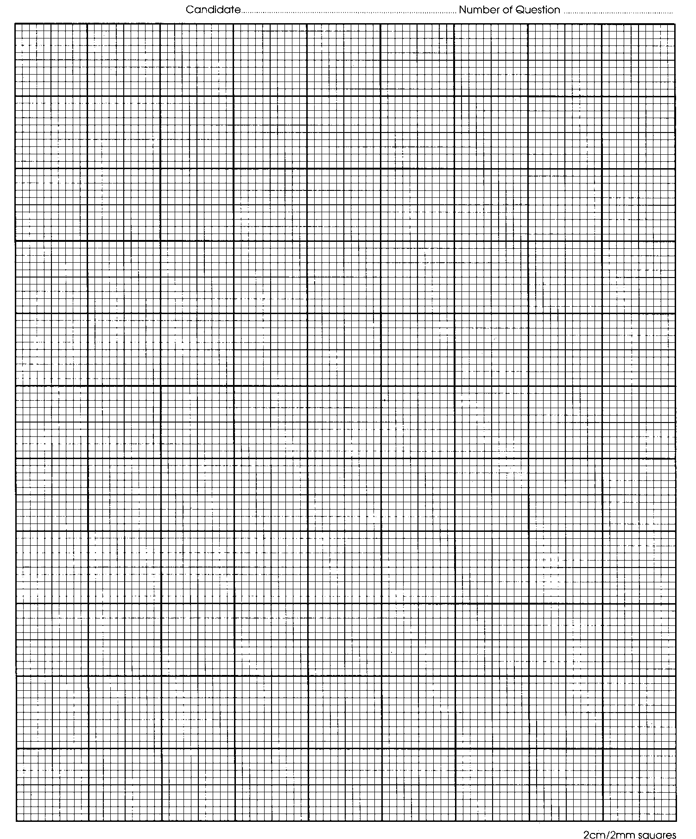

λ_{max} for haemoglobin is: ____________________________________________________

4. Draw the absorbance spectrum of vitamin B12.

λ_{max} for Vitamin B12 is: ____________________________________________________
5. Draw the elution profile after gel filtration.

On the profile, mark V₀, and the V_{e} for Vitamin B12.

4. a. Complete the following purification table

step | Volume | Total protein (mg) | Total activity (units) | Specific activity (units/mg protein) | Purification fold | Yield (%)
Homogenate | 900 | 43600 | 48000 |  | 1 | 100
pH 4.2 supernatant | 650 | 4760 | 28000
(NH₄)₂ ppt | 140 | 1008 | 18667
Gel Filtration chromatography | 57 | 7.1 | 7410
Ion-exchange chromatography | 35 | 2.45 | 3266

b. Comment on the effectiveness of the gel filtration step in the purification giving reasons for your answer.

______________________________________________________________________________________________________________________________________________________________________________________________________________________________________________________________________________________________________________________________________________________________________________________________________________________________________________________________________________________________________________________________________________________________________________________________________________________________________________________________________________________________________________________________________________________________________________________________________________________________________

PRACTICAL: CELL COUNTING USING THE TRYPAN BLUE EXCLUSION METHOD

Purpose
This document describes the procedure to count cells using the Trypan blue exclusion method.

Equipment
Microscope
Pipettes and associated tips
Haemocytometer and glass coverslip

Safety Precautions
1. Good laboratory techniques are to be used at all times.
2. Any material that has been in contact with human, murine, or GM cell lines is treated as potentially infectious.
3. Wear gloves and lab gown at all times.
4. Always decontaminate waste as soon as possible.
Background of Haemocytometer Counting - This is probably the most convenient and practical method of counting cells in suspension culture or in dispersed monolayer culture. The haemocytometer was invented by Louis-Charles Malassez in 1885 and later modified by Neubauer. The haemocytometer consists of two chambers, each of which is divided into nine 1.0 mm squares. A cover glass is supported over the chambers and cell suspensions are introduced under the cover glass. The haemocytometer is placed on the microscope stage and the cell suspension is counted.
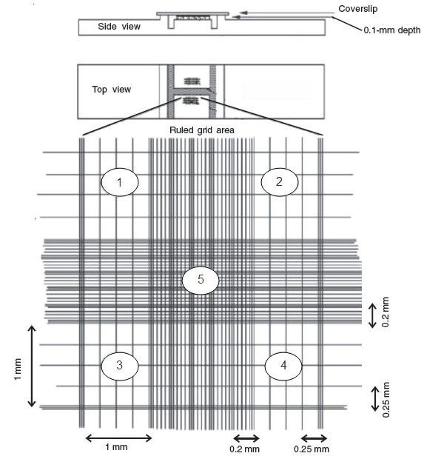
The ruled area of the haemocytometer consists of several large 1 x 1 mm (1mm²) squares, which are subdivided into 16 squares of 0.25 x 0.25 mm (0.0625 mm²) each. The central, 0.20 x 0.20 mm (0.04 mm²), is further subdivided into 0.05 x 0.05 mm (0.0025 mm²) squares.
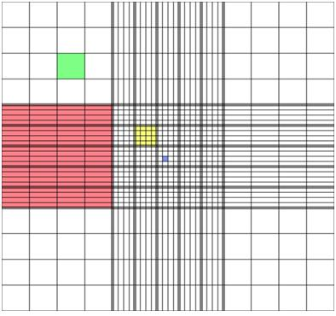
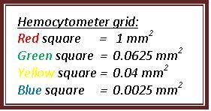

Figure 1. One chamber of a haemocytometer with Neubauer ruling.
A number of stains have been employed to distinguish between live (viable) and dead (nonviable cells). Trypan blue, Erythrosine B, and Nigrosine, are excluded by the membrane of "live" cells. In dead or damaged cells, the stain enters the cytoplasm and the cells take up the stain. If more than 20% of the cells are stained, the cell suspension is most likely not to be a viable one.
Haemocytometer counts are, however, subject to the following sources of error:
(1) Non-uniform suspensions
It is assumed that the volume of cell suspension placed into the chamber represents a truly random sample. This will not be a valid assumption unless the suspension is monodisperse and free of cell clumps. Unless 90% or more of the cells are free from contact with other cells the count should be repeated with a fresh sample from the original culture. Clumping can be minimized by keeping the suspension in an ice bath in plastic tubes, and by using a diluent without calcium and magnesium. Always mix thoroughly before sampling!
(2) Improper filling of chambers
Hold the cover slip (0.1 mm) at the raised edges of haemocytometer, which gives each square a defined volume. In order to fill properly by capillary action, a haemocytometer chamber must be scrupulously clean and this also applies to the pipet used to fill the chamber. In a laboratory where the haemocytometer is in regular use throughout the day, following rinsing with water after use, it, and the coverslip, may be placed in a small beaker containing soapy water so that it is always ready for its next use. The chamber and cover slip are cleaned first with distilled water, then by 70% ethanol and wiped dry with a Kimwipe. If the cell suspension does not flow in and fill the chamber immediately and smoothly when the drop from the pipet is placed in the depression under the coverslip, the chamber is dirty and should be re-cleaned.
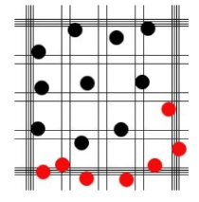
(3) Failure to adopt a convention for counting cells in contact with boundary lines or with each other. See Figure 1. This diagram is what you would see when looking down onto the haemocytometer under the microscope at low power (i.e. 4-10X). There are two chambers in the haemocytometer. This diagram depicts one of the two chambers (having 9 squares). A coverslip sits on top of the haemocytometer enclosing both chambers, creating a space into which is loaded the cell suspension. There is a "V" or notch at either end which is the place where the cell suspension is loaded into the haemocytometer. Some cells can settle on the border gridlines and so it becomes difficult to decide whether or not to count such a cell. Is it in or is it out? In order to determine what to count and what not to count, concerning a cell on a boarder, one should develop a convention in which one does not count half of the cells that touch a boarder. You MUST be consistent.
For purposes of this practical, you will only count cells touching the top and left border (count ‘black’ and not ‘red’ as shown in figure). You will count the cells in four large corner squares (i.e. those divided further into sixteen small squares).
(4) Statistical error
With careful attention to detail, the overall error can be reduced to between 10% and 15%.
CALCULATIONS
1. Each of the nine squares making up the haemocytometer chamber is: 1mm x 1mm = area of 1mm²
2. With the coverslip on the chamber, the coverslip sits 0.1mm over the chamber. Therefore, the volume of each square, contained under the coverslip is:
1mm x 1mm x 0.1mm = 0.1mm³ or 10 ⁻⁴ cc
(10mm = 1cm; 1mm = 0.1cm; 1mm ³ = 10⁻³ cubic centimetres (cc) or ml; 0.1mm ³ = 10⁻⁴cc or ml (the vol. of 1 square)]
A. The total number of cells per ml will be determined using the following calculations:
Quadrant | #Live Cells | #Dead Cells | Total # Cells
1
2
3
4
Average #cells:

B. Calculate the average #cells from chamber

Average # Average # Average #
Live Cells ____________ Dead Cells____________ Total Cells____________

C. Calculate the cell density or Total cell concentration in the original suspension (in cells/ml) is:

# Cells/ml = (Average # total cells) X dilution factor X 10⁴
  - Dilution Factor = Total Volume (Volume of sample + Volume of diluting liquid) / Volume of sample. The dilution factor for this example is 2 because 0.05 ml of cell suspension was diluted with 0.05 ml Trypan Blue.
# Cells/ml = _____________ X 2 x 10⁴

# Cells/ml = ____________

D. Calculate cell viability

Average # live cells / Average # total cells x 100

______________ / ______________ x 100

Cell viability = ____________%

Precautions:
- Type of counting chambers: There are different types of counting chambers available, with different grid sizes. Some counting chambers also have grids of different sizes. Take care to know the grid height and size otherwise you will make calculation errors.
- Use the provided cover glasses: They are thicker than the standard 0.15mm cover glasses. Therefore they are less flexible and the surface tension of the fluid will not deform them. The height of the fluid is standardized this way.
- Objective: The haemocytometer is thicker than a regular slide. Be careful to not crash the objective into the haemocytometer at the time of focusing.
- Use an appropriate dilution of the mixture with regard to the number of cells to be counted. If the sample is not dissolved well, the cells become crowded and will be difficult to count. If it is too dissolved, the sample size will not be enough to develop strong inferences about the concentration in the original mixture. Bubbles are removed from the haemocytometer before counting.
Extra resources (Link to videos)

https://www.youtube.com/watch?v=wPeNK0pRIpA

http://www.lsteam.org/projects/videos/counting-cells-hemocytometer

EXPERIMENT
The purpose of this laboratory exercise is to acquaint you with some of the fundamentals of culturing cells in vitro.
(1) What do cell cultures look like?
(2) Where do the cells grow?
(3) What do the cells in the culture look like?
In this exercise you will:
(1) Observe the cell culture provided;
(2) Count cells to determine how many cells were in the original plate.
(3) Determine the viability of cells.
MATERIALS
- Haemocytometer plus a supply of cover slips.
- 0.4% Trypan Blue stain (fresh & filtered) in phosphate buffered saline.
- Cell Suspension.
- Micropipettes and tips.
- Inverted microscope.
PROCEDURE
1. Visualize cells under microscope

Three plates with different confluency of the cells will be presented to the class. You will go in groups to visualize these three plates under microscope. Focus the microscope using knobs and see cells under 10X. Take note of the distribution and morphology of cells in each plate. Note down what you have observed and answer the questions in the assignment.

2. Prepare the haemocytometer

- Clean the haemocytometer and glass coverslip by spraying with 70% ethanol and wiping dry with a Kimwipe.
- Position the haemocytometer correctly with the glass coverslip in the middle of the haemocytometer.

3. Prepare a 1:1 dilution of the cell suspension in trypan blue
- You will be given a cell suspension (20 µl) in a microfuge tube. Add 20 µl 0.4% Trypan blue to cell suspension.
- Mix dye and cells thoroughly by gently pipetting three times.
4. Load the haemocytometer
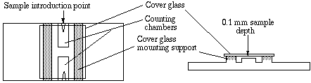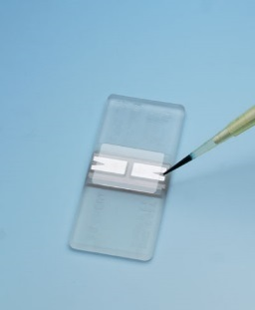
- Pipette 10 μl of the cells/trypan blue mixture into one side of the haemocytometer. The cell suspensions should be allowed to flow under the coverslip until the grid area is just full and not overflowing into the overflow well.
- If the chamber is loaded too heavily, clean it and begin again.
- Allow cells to settle. If greater than 10% of the cells appear clustered, repeat entire procedure making sure the cells are dispersed by vigorous pipetting in the original cell suspension as well as the Trypan Blue-cell suspension mixture.
5. Determine the number of cells (total, live and dead):
- Live (Viable) cells exclude the Trypan blue, while dead (nonviable) cells take up the dye. After being stained with Trypan blue, the cells must be counted within three minutes; after that time viable cells begin to take up the dye.
- With the microscope, using a 4x objective, identify the nine main squares of the counting chamber. Count cells on 10x magnification on the microscope or higher if necessary to clearly visualise the cells. Ideally, count 100-200 cells to ensure accuracy.
- Count numbers of both live and dead cells using the counter.
- Count cells in 4 large corner squares. Count rows or columns. Use the gridlines to help remember which areas' cells have already been counted.
- Do not count cells touching ‘right’ and ‘bottom’ borders of the square.
6. Calculations
Do calculations as shown above.

7. Cleaning the haemocytometer
Clean the instrument as soon as possible after use. For drying the excess liquid do not use paper wipes. The capillary action that filled the chamber will then dry it out. After using trypan blue, rinse the haemocytometer with distilled water to remove the dye and allow it to dry. Clean the instrument with 70% isopropanol. Air dry. Dispose of trypan blue contaminated articles in biohazard waste. Use protective clothing, gloves and eyewear. Trypan blue is a mutagen.

Practical Report: Cell Counts Using the Trypan Blue Exclusion Method
(MCBG 2036, Prof M Kaur)

Person Number_______________ Date_________________ Marks: 20
A. The total number of cells per ml are: (3 marks)
Quadrant | #Live Cells | #Dead Cells | Total # Cells
1
2
3
4
Average #cells:

B. Calculate the average #cells from chamber (3 marks)

Average # Average # Average #
Live Cells ____________ Dead Cells____________ Total Cells____________

C. Calculate the cell density (1 marks)

D. Calculate cell viability (1 mark)

2. What is the principle behind Trypan Blue Exclusion Test of cell viability?
(1 mark)

3. Name two dyes except Trypan Blue which are used to differentiate between live and dead cells? (2 marks)

5. You have seen cells under microscope. Answer the following using your observation:
a. What is the confluency of cells in each plate? Write your answer in percentage. (3 marks)
Plate 1:
Plate 2:
Plate 3:
b. What is the morphology of the cells that you have observed under the microscope?
(1 mark)

c. Are these adherent or non-adherent cells? (1 mark)

6. If we add 300 µl PBS (Phosphate buffered saline) and 500 µl Trypan Blue to 200 µl cells, what would be the dilution factor that you will use for calculating cell concentration per ml?
(1 mark)

7. In a haemocytometer, how many 0.0625 mm² squares are there in one chamber with an area of 1 mm²? (1 mark)
a. 9
b. 25
c. 16
d. 4
e. 15

8. Find the percentage of viable cells, if there is a total of 150 cells including 120 unstained cells. (1 mark)

a. 80
b. 65
c. 75
d. 70
e. 90

9. When first focusing your microscope you should use the low power objective. (1 mark)

a. True
b. False

PRACTICAL: Virtual ELISA

50 marks

Answer the questions on a separate page. Include a cover sheet and your student number.

1. Open this website: http://www.hhmi.org/biointeractive/immunology-virtual-lab
2. Click on “start virtual lab”. A new window will pop up; change the size to fill the screen.

3. Read the section entitled “Diagnosis”. Answer the questions below.
3.1. What does ELISA stand for? (1 mark)
3.2. What are ELISA assays used for in laboratories? (1 mark)
3.3. What are the three important limitations of an ELISA? Explain each. (3 marks)

4. Read the section entitled “Background”. Answer the questions below.
4.1. What is the difference between serum and plasma? Do they both contain antibodies? Why is serum preferred in this assay? (1 mark)
4.2. What is a secondary antibody? (1 mark)
4.3 What is the difference between a primary antibody and a secondary antibody? (1 mark)
4.4. Click on Figure 1. What are the 5 major steps of an ELISA to detect antibody titre? (5 marks)
4.5 Draw a labelled diagram showing what samples and reagents will be present in the final step of an ELISA and how they interact or associate with each other. (5 marks)

(After viewing Figure 1, click on “go back to previous page” to return to the Background section).

5. Click on the section entitled “Notebook”.
Proceed through the entire lab simulation protocol.
Follow the instructions in the virtual lab (pictures on left side). Click on reagents and equipment where necessary.
You can also read the information in the lab notebook (right side).
You can "start over" to begin the lab again. You CANNOT skip any steps.
Answer the questions as you proceed.

Introduction. You are sent 40 ml blood from three different patients and need to test each sample for systemic lupus erythematosus (SLE). You must conduct an ELISA to look for antibodies characteristic of this disease.
5.1 What is SLE? (2 marks)

Step 0 (not shown): An ELISA plate is prepared by adding SLE antigen to each well of a plastic 96-well plate. The coating procedure must be done carefully. If too little antigen is used, bare spots will permit antibody or other protein to stick, leading to a false-positive reaction. If too much antigen is used, the excess will be able to bind SLE antibody from patient sera but then will be washed away, creating a false-negative reaction. The addition of antigen is the crucial first step in the chain of recognition events between antigen and antibody that will end with the formation of colour from the enzyme bound to the second antibody.
(After the introduction, click on left side picture to continue; follow the instructions.)

Step 1. Centrifuge whole-blood samples of patients A, B, and C for 15 minutes at room temperature.
5.2 Why is the fourth tube (with purple lid) added during the centrifugation step? (1 mark)
5.3 After centrifugation, the whole blood has separated into layers with different colours. What do these represent? (1 mark)
(Click on serum A to continue; follow the instructions.)

Step 2. Using the serum from patient A, prepare three dilutions as follows:
- Take 1 ml of serum from patient A and add 1 ml of phosphate-buffered saline (PBS) solution. This is a 1:2 dilution.
- Take 1 ml of serum from patient A and add 9 ml of PBS. This is a 1:10 dilution.
- Take 0.1 ml of serum from patient A and add 9.9 ml of PBS. This is a 1:100 dilution.
(this step is repeated for samples B and C).

5.4 Did you notice that in this virtual simulation, the blue and yellow colours of the large volume and small volume pipettors are not the same as colours in our real life lab! In our real life lab, our biggest micropipette has a blue top and uses blue plastic tips. What are the maximum and minimum volumes that this type of pipette can be used for? (1 mark)

5.5 Why are dilutions of serum performed in Step 2 and why is PBS used? (2 marks)
(Click on small volume pipettor to continue; follow the instructions.)

Step 3. Add 0.1 ml of each of the different dilutions of patient serum to an ELISA plate using an pipettor. Remember: The ELISA plate was pretreated to bind SLE antigen to each well. The following plate set-up is used.

 | Sample A | Sample B | Sample C | Positive | Negative
Dilution 1:2
Dilution 1:10
Dilution 1:100

(Click on “put serum A away” to continue; follow the instructions.)
(Click on “put serum B away” to continue; follow the instructions.)
(After adding serum C, click on “add the SLE antibody” to continue; follow the instructions.)

Step 4. Add 0.1ml of SLE antibody as a positive control to the ELISA plate (add 0.1ml to three wells). 0.1ml of a negative control is added to the ELISA plate (add 0.1ml to three wells).

5.6. What is the purpose of a positive control and what is the purpose of a negative control? (2 marks)
5.7. Why is SLE antibody used as a positive control? (1 mark)
5.8 What could be used as a reagent for the negative control ? (1 mark)
(Click on “the ELISA plate” to continue; follow the instructions.)

Step 5. Incubate the ELISA plate at 37° C for 15 minutes.
5.9. Why is an incubation step performed? (1 mark)

(Click on “the ELISA plate” to continue; follow the instructions.)

Step 6. Wash. Remove the fluid from each well with the small volume pipettor .
After all liquid is removed, click on the buffer. Add 0.1 ml of PBS buffer to each well.
Click on the small volume pipette to again remove all fluid from each well.
Often, in a real laboratory, these washes are repeated 3-6 times prior to adding the next substance. In order to speed this example along, we have given just one rinse/wash example per step.

5.10 Why is this wash step performed? What would happen if you did not perform this step? (2 marks)
5.11 What remains in the wells? (1 mark)
(Click on “the rabbit anti-human antibody” to continue; follow the instructions.)

Step 7. To each well, add 0.1 ml of a solution containing a secondary antibody. This secondary antibody was made in a rabbit and has an attached enzyme (HRP) that will interact with the substrate in the next step.
5.12 What will the secondary antibody bind to? and is it specific for SLE? (2 marks)
(Click on “the ELISA plate” to continue; follow the instructions.)

Step 8. Incubate the ELISA plate at 37° C for 15 minutes.
5.13. Why is this incubation step performed? (note : your answer should not be identical to the answer for Q5.9). (1 mark)
Step 9. Wash.
Remove the fluid from each well with the small volume pipettor .
After all liquid is removed, click on the buffer. Add 0.1 ml of PBS buffer to each well.
Click on the small volume pipette to again remove all fluid from each well.
5.14 What is being removed during this wash step and what is left in the wells? (note: your answer should not be identical to the answer for Q5.10-5.11). (2 marks)
(Click on “the HRP substrate” to continue; follow the instructions.)

Step 10. Add 0.1 ml of buffered solution containing the chemical substrate (HRP-substrate) to each well. If there are human antibodies present, the clear substrate will turn yellow.
5.15 What substrate is used? (1 mark)
5.16 How would the yellow colour be measured? (What instrument / what wavelength?) (2 marks)
(Click on “the ELISA plate” to continue; follow the instructions.)

Step 11. Wait for 15 minutes.
(Click on “the ELISA plate” to continue; follow the instructions.)

Step 12. Results. Enter your results in the table on the screen.
5.17 From which observations can you determine that a test result is false negative? Why would a false negative result occur (give at least three possible reasons)? (5 marks)
5.18 From which observations can you determine that a test result is false positive? Why would a false positive result occur? (5 marks)
5.19 If the following results were obtained, where X means detectable yellow colour, what would these test results mean for samples A, B and C? (3 marks)
 | Sample A | Sample B | Sample C | Positive | Negative
Dilution 1:2 | X | X |  | X
Dilution 1:10 | X | X |  | X
Dilution 1:100 | X |  |  | X

Section B.
In the example below, ELISA was used to test for antibodies against HIV . Go to:
http://www.biology.arizona.edu/immunology/activities/elisa/main.html
Read through the brief information under
- background
- methods
- false positives
- data interpretation.
- (all of these sections are similar to what you already know).
Answer the four multiple choice questions below (as shown on the website).
5.20 What is the ELISA test intended to measure? (1 mark)
- Antibody to HIV only
- Antigen to HIV only
- Presence of free, circulating virus in the patient
- Antibodies directed against HLA molecules
5.21 What would happen if serum were omitted from the ELISA, but all other steps remained the same and were performed properly? (1 mark)
- Anti-human Ig-conjugate would not bind and be washed away.
- Anti-human Ig-conjugate would bind non-specifically to the ELISA plate.
- The optical density values would be nearly the same as the assay control.
- Both A and C.
5.22 What would happen if the anti-human Ig-conjugate were not washed free of the well before the substrate was added? (1 mark)
- The ELISA would not develop when the substrate was added.
- The ELISA would develop normally.
- All wells would show uniform over development due to unbound and excess anti-human Ig enzyme conjugate.
- Both A and B.
5.23. From the ELISA data below, which patient is seropositive for HIV? (1 mark)
For this test, values are expressed as optical density at 450 nm. The cut-off value indicating a positive result is 0.500. Optical densities of 0.300 to 0.499 are indeterminate and need to be retested. Values below 0.300 are considered to be negative. (An assay control is just a patient sample with a known result, like another positive control).
Positive control | Negative control | Patient A | Patient B | Patient C | Assay control
1.689 | 0.153 | 0.055 | 0.412 | 1.999 | 0.123
- Patient A
- Patient B
- Patients B and C
- Patient C
5.24 If a person tested positive on an HIV ELISA test, does this mean with 100% certainty that he is infected with HIV? (1 mark)
5.25 What test/s would next be performed to confirm an HIV infection and how would this differ from an ELISA test? (1 mark)

PRACTICAL: KEY TECHNIQUES IN BACTERIOLOGY I

Prof Gustav Bouwer (Bacteriology)

IMPORTANT SAFETY WARNING
Many microorganisms are agents of decay, death, and disease. Although microorganisms of low virulence are used in most microbiological laboratory experiments, all microorganisms should be treated as potential pathogens (a pathogen is an organism capable of causing disease). Laboratory rules and regulations are formulated to protect the experimenter from laboratory accidents and potential pathogens. Pathogens do not discriminate - you have a social responsibility towards your classmates and community. Laboratory rules and regulations are not only required for personal and environmental safety, but also promote the efficient performance of laboratory exercises and research.

GENERAL
- It is expected that you will have read and thoroughly acquainted yourself with the subject matter before coming to class. Plan and organize the activities required for the experiments.
- Before entering the laboratory ensure that you have the following:
- Laboratory coat.
- Laboratory manual and notebook or note paper.
- Matches or a lighter.
- Permanent (water resistant) marker. The marker must have a thin tip.
- Ensure that you are wearing appropriate shoes - closed shoes should be worn. Sandals or other open shoes are not allowed.
- When working with bacteria, it is very important to practice certain aseptic techniques to make sure that cultures being studied are not contaminated by organisms from the environment or that organisms are not released into the environment. The following steps will reduce contamination of your experiments:
- Wipe the lab bench with disinfectant before and after lab activities.
- Wash your hands before and after performing an experiment.
- Using the Bunsen burner, flame all non-flammable instruments used to manipulate bacteria or fungi before and after use.
- Place swabs and tooth picks in the disposal container immediately after use. Never place one of these items on the lab bench after use!
- Wear a lab coat to lessen chances of staining or contamination accidents.
- Properly label all of the materials to be used in the experiments. This is especially important for experiments in which class marks are allocated in the days following the laboratory session. Ensure that your name and student number are on these materials.
- Please remember to put your name and student number on any reports that you hand in along with your laboratory partner’s name in brackets.
- All follow-ups to practicals are compulsory.
- Unlabelled test tubes and petri dishes will be discarded. All dirty and used glassware should be returned promptly to the receptacles provided. All pipettes should be placed in the receptacles provided.
- Note that all material covered in practicals is examinable.

SUMMARY OF THE LABORATORY SESSION
Part A: Pure culture of bacteria
Experiment 1: The streak plate technique and cultural characteristics of bacteria
Part B: Staining techniques and bacterial morphology
Experiment 2: Simple staining of bacteria
Experiment 3: The Gram stain

PART A: Pure culture of bacteria
EXPERIMENT 1: The streak plate technique and cultural characteristics of bacteria
Background
In order to study a particular microorganism one must have a “pure culture” of the organism, i.e. a culture which is free from any other contaminating species or variety of microorganism. A large number of microorganisms are present in our environment (in the air, water and soil). These natural inhabitants are removed from all equipment and media used in microbiological work by sterilization, but they can be reintroduced during the experimental work if aseptic techniques are not observed. Aseptic techniques are also necessary to prevent culture organisms, which are possibly pathogenic, from being distributed into the environment.

The streak plate procedure is used to separate the individual bacterial species present in a mixed culture. It depends on the principle that bacteria can be spread sparsely on the surface of a nutrient agar plate where, in almost all instances, a single bacterium grows into a discrete mass of bacteria to form a so-called colony. Cells can be transferred with an inoculating needle or loop from this colony into a culture tube of medium, where only one type of organism will be present and multiplies into a pure culture.

Demonstrations by Teaching Assistants
The Teaching assistants will demonstrate the following techniques:
- Principles of aseptic techniques.
- Flaming of inoculation loops and bottles/tubes.
- Opening of bottles/tubes.
- The streak plate technique (from broth cultures and isolated colonies).
- Transfer of culture between containers.
- Inoculation of an agar slant.

Materials
Mixed suspension of Micrococcus luteus and Staphylococcus aureus
Nutrient agar plates
Nutrient agar slants
Inoculating loop

Procedure
- Preparation of a streak plate
- By the technique demonstrated in Figure 1 and as shown by your Teaching Assistant, streak the surface of the nutrient agar plate (NA) with the mixed suspension of bacteria.
- Incubate the plate upside down at 37ºC in the boxes provided for 24 to 48 hours.
- Observe the plates for isolated colonies. Describe the colonies as to: form, elevation, margins, pigmentation (colour) and size (diameter) (see Figure 2A for assistance), and record your results in Table 1 (see Laboratory Report section below).
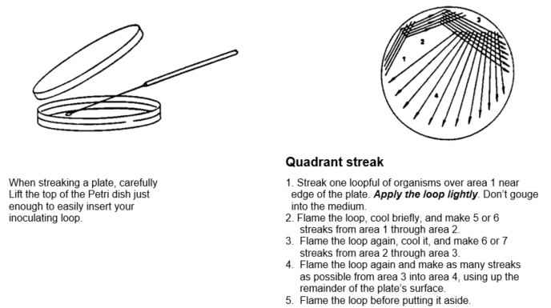
Hints and precautions:
- Each time the loop is flamed, allow it to cool briefly on the agar before streaking the culture. Wait until the loop stops “hissing”.
- Use a loopful of culture from the inoculum’s tube only when applying the first streak in the plate. Do not return to the inoculum tube for more culture when streaking for the second and subsequent times.

Figure 1. The streak plate procedure.
- Isolation of pure culture (follow up)
- With an inoculating loop, carefully touch the colony and transfer onto a NA slant. Repeat this transfer procedure for the other colony type onto a separate NA slant.
- Leave the slants at room temperature and observe the growth in your own time (2-3 days).
- Describe the cultural characteristics of the agar slant cultures according to the key given in Figure 2B, and fill in your answer in Table 2 (see Laboratory Report section below).

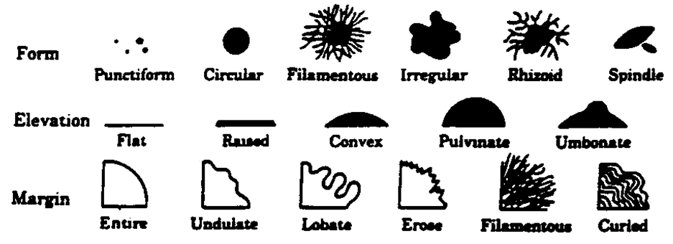

B
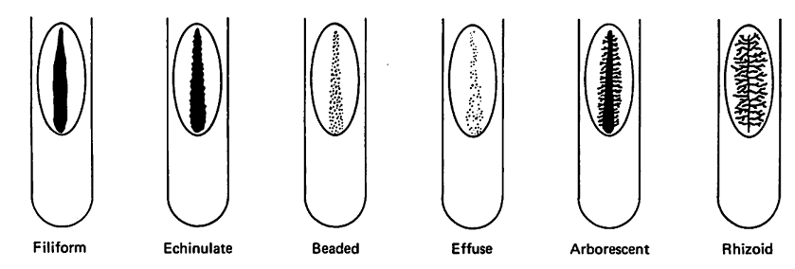
Figure 2. Cultural characteristics of bacteria. A. Colonies on agar plates, B. Growth on agar slants.

Laboratory report and mark allocation for Part A

Complete the following tables (see Experiment 1).

Table 1. Colony morphology of isolated colonies.
Colony 1 | Form | Elevation | Margin | Pigment | Diameter (mm)
Colony 2 | Form | Elevation | Margin | Pigment | Diameter (mm)

Table 2. Cultural characteristics of agar slant cultures.
Culture | Characteristics
Agar slant culture 1
Agar slant culture 2

Mark allocation for Experiment 1
  - Your streak plate will be evaluated and marks allocated for the quality of your streak plate technique. (10 marks)
  - Your agar slants will be evaluated and marks allocated for the quality of your slant inoculation.
(5 marks)
TOTAL MARKS = 15
PART B: Staining techniques and bacterial morphology
Their small size necessitates the use of a microscope in the cytology (the study of cells) of bacteria. Although a microscope sufficiently enlarges bacteria to allow individual cells to be seen, lack of contrast is an ever-present problem in bacterial cytology. The lack of contrast arises because both the microorganisms and the media in which they are normally suspended are largely composed of water. Thus, microorganisms that are suspended in an aqueous medium are transparent and practically colourless. Contrast is critical for the visualization of objects - imagine trying to study water-filled transparent plastic bags in a swimming pool. Stains are used to enhance the contrast between the specimen and the background. A stain is a compound that, when in solution, combines specifically with certain other compounds and imparts a colour to these compounds. Staining procedures can be divided into two main groups: simple or complex staining procedures. In the following experiments, you will perform both simple and complex staining procedures.

EXPERIMENT 2: Simple staining of bacteria
Background
In simple staining, a single stain reagent is used, and the procedure does not try to produce different staining reactions for different structures or types of bacteria. Simple staining depends on the fact that, in aqueous environments at around pH 7, bacteria and other cellular organisms have a net negative charge. In microbiology, the main function of simple staining is to elucidate the morphology and arrangement of bacterial cells. Simple staining of microorganisms can be either positive or negative:
Simple positive staining: A basic (cationic) stain is used. The stain has a positively charged chromophore that is attracted to the negatively charged surface of the microbial cell. The stained cells appear dark or coloured against a light or clear background. Basic stains are the most commonly used stains in microbiological work. Examples include methylene blue, crystal violet, and safranin.
Simple negative staining: In this staining procedure the microorganism itself is not stained. An acidic (anionic) stain is used. The stain has a negatively charged chromophore that is repelled by the negatively charged surface of the microbial cell. Thus, only the background is stained and the microorganisms appear bright on a dark background. Nigrosin is an example of an acidic stain. Negative stains provide little information about the chemical nature of the cells, but are useful in determining the size and shape of cells. Negative stains are also used to examine microorganisms that are difficult to stain with the usual laboratory stains. Another advantage of negative staining is that living cells can be studied - basic stains usually kill the stained cells.

Demonstrations by Teaching Assistants
The Teaching assistants will demonstrate the following techniques:
- Preparation of smears for staining.
- Heat fixation of smears.
- The procedure for simple staining.
- Demonstration of microscope usage and cleaning.

Materials
24-hour broth cultures of Escherichia coli
Staphylococcus aureus
Methylene blue
Glass slides
Inoculating loop

Procedure
- Prepare separate bacterial smears of each of the bacteria, air dry and heat fix, as demonstrated. All microbiological staining procedures require the preparation of microbial smears.
Notes on preparing a smear:
- One or two loopfuls of suspended cells should be directly applied to the glass slide at one end with sterile inoculating loop and spread evenly over an area about the size of a 5 cent piece.
- Heat fixation: Unless fixed to the glass slide, bacterial smear will wash away during the staining procedure. This is avoided by heat fixation during which the bacterial proteins are coagulated and fixed to the glass surface. Heat fixation is performed by the rapid passage of air-dried smears 2 to 3 times through the flame of the Bunsen burner. The slide should feel warm to the touch. If you under-heat, the cells will wash off the slide; if you overheat the cells they will “fry” and lose their integrity and shape.
- Avoid thick, dense smears. A good smear, when dried appears as a thin whitish layer of film.
- Flood slide with stain, leaving stain for 1 minute.
- Wash smear with tap water to remove excess stain. The slide should be held parallel to the stream of water, to prevent the loss of organisms from the preparation.
- Blot dry but do not wipe the slide.
- Examine the stained slides under oil immersion. (NB: ALWAYS focus under the 10x objective first, then the 40x objective, then add oil and use fine focus ONLY for the 100x objective). If the smear is too thick (individual cells cannot be easily discerned); if it is too thin (cells must be searched for through several fields), make adjustments in your smear preparation as required.
6. Describe the organisms with reference to their colour they stain, shape (bacillus, coccus, spirillus, etc.) and arrangement (chains, clusters, pairs or tetrads) in Table 3 (see Laboratory Report section below).
EXPERIMENT 3: The Gram stain
Background
Complex staining procedures are staining procedures in which more than one stain is used. These staining procedures can be used to highlight a specific cellular structure to aid the identification and study of the structure or they can be used to differentiate between groups of bacteria. The most important differential stain used in bacteriology is the Gram stain. It divides bacterial cells into two major groups, Gram-positive and Gram-negative and is known as a differential stain. This stain divides cells into two major groups, Gram-negative and Gram-positive bacteria, on the basis of their ability to retain a stain in the presence of a decolouriser - an ability that is related to cell wall composition and structure.

The cell walls of Gram-positive bacteria are structurally different from those of Gram-negative bacteria. A Gram-positive bacterium has a thick layer of peptidoglycan associated with techoic acids, whereas the cell walls of Gram-negative bacteria have a thin peptidoglycan layer and an outer membrane consisting of lipopolysaccharide, protein, phospholipid, and lipoprotein. The difference in lipid concentration between the Gram-positive and Gram-negative cell walls is the primary reason for the difference in stain retention between the two cell types. Gram-positive bacteria are able to retain the primary stain (crystal violet; purple) after the cells have been treated with a mordant known as Gram’s iodine; whereas Gram-negative bacteria will have the primary stain extracted by the decolourizing agent (the alcohol). These colourless cells will then show the counterstain (safranin; pink/red) whereas this stain will not appear in the purple primary stained cells. Microscopic observation of Gram-stained bacteria also provides an opportunity to note bacterial morphology (shape and arrangement).

Materials
24-hour broth cultures of Escherichia coli
Bacillus subtilis
Inoculating loop
2 slides
Gram stain reagents; crystal violet, Gram’s iodine, decolouriser, safranin.
Procedure
- On two separate glass slides, prepare a smear of each of the two organisms, air-dry and heat fix.
- Flood the smears with crystal violet and let stand for 1 minute.
- Wash with tap water.
- Flood smear with gram’s iodine mordant and let stand for 1 minute.
- Wash with tap water.
- Decolourise with decolouriser (acetone + iodine). Caution: do not over-decolourize. Add decolourszer dropwise to slanted slide until only faint colour is noted in the decolouriser
- Wash with tap water immediately.
- Counterstain with safranin for 1 minute.
- Wash with tap water, drain and allow to dry.
- View under oil immersion (100x objective). (NB: Always focus under the 10x objective first, then the 40x objective, then add oil and use fine focus only for the 100x objective).
- Draw an annotated, representative field of view for the Gram stain under oil immersion magnification. The annotations should include the shape, arrangement, colour and Gram reaction of each of the cell types you observe. IMPORTANT: Call your Teaching Assistant once you have drawn your field of view – he/she will evaluate and grade your field of view. Record your results as stipulated under the section “Laboratory report and mark allocation for Part B”.

Laboratory report and mark allocation for Part B
IMPORTANT: The laboratory report for Experiment 2 and 3 must be submitted before you leave the practical.
Experiment 2
Complete the following table.
Table 3. Cell morphology and arrangement.
Cell type | Colour | Shape | Arrangement
1
2

(5 marks)
Experiment 3
- Draw an annotated, representative field of view for the Gram stain under oil immersion magnification. The annotations should include the shape, arrangement, colour and Gram reaction of each of the cell types you observe.

(20 marks)
- Your Teaching Assistant will evaluate and grade the field of view that you have chosen to draw.
(5 marks)
TOTAL MARKS = 30
PRACTICAL: KEY TECHNIQUES IN BACTERIOLOGY II
(Prof Bouwer)
SUMMARY OF THE LABORATORY SESSION
Enumeration of bacteria
Experiment 1: Haemocytometer counts
Experiment 2: Preparation of serial dilutions
Experiment 3: The pour plate method
Experiment 4: The spread plate method
Enumeration of bacteria
Background
Studies involving the analysis of material such as food, water, milk or soil require quantitative enumeration of microorganisms in the samples. The number of bacteria in a sample can be assessed either by total counts or by viable counts.
- Total counts
All the organisms present are counted. No differentiation is made between living and dead bacteria, but total counts are less time consuming than viable counts. There are a number of methods that measure directly all cells in a sample:
- Counts of stained films
A known volume of sample is spread over the area of 1 square centimeter on a slide and the film is dried, fixed and stained. The numbers of microorganisms in a large number of microscopic fields is then determined. Since the area of the microscopic field can be determined, the bacterial count can be calculated. This method is commonly used for the determination of the number of bacteria in milk.
- Electronic counters
Cells or particles may also be counted electronically with electronic counters, such as the Coulter counter. A sample is passed through a small opening. The electrical resistance across the hole is standardized and each time an organism passes through, this resistance is altered. From the measured change in the electrical resistance not only the numbers of cells, but also their size can be determined. However, since this method measures any particle in the sample it is applicable only to aqueous suspensions of microorganisms and cannot be used to determine the number of organisms in soil for example.
- Measurement of the cell mass
The measurement of the cell mass of a culture estimates the total cellular protoplasm per ml of culture. The most common methods for determining cell masses are:
  - Chemical estimates of cellular components. For example, cellular nitrogen, protein or DNA.
  - Dry weight methods. The culture is harvested by centrifugation or filtration, the cells are washed and their weight determined after drying.
  - Cell volume methods. A standard quantity of liquid culture is placed in a calibrated centrifuge tube and the volume of the wet pellet is measured after centrifugation.
  - Light scattering or turbidimetric methods. A population of cells in a liquid medium blocks or scatters light in proportion to their total mass in the culture.
- Direct microscopic count
A special slide called a haemocytometer is used. The slide has a central platform which is surrounded by a ditch. The counting grid is engraved in the centre of the platform (see Figure 1 below). The procedure for determining the concentration of cells in a suspension with the improved Neubauer haemocytometer is outlined in Experiment 1 below. Other haemocytometers are used in a similar way, but their dimensions and grid patterns may differ.
- Viable counts
These methods count only living bacteria. The sample is usually serially diluted and aliquots placed in or on a suitable culture medium. Each colony developing is assumed to have grown from one viable cell or a colony forming unit. Because viable counts are performed by counting colonies, they are also called colony counts. Since only living cells will reproduce and form colonies, a colony count is an effective way of distinguishing between viable and dead cells in a suspension. There are several different viable count methods:
- The pour plate method
The microbial suspension is mixed with liquefied solid medium and the mixture is poured in a petri dish. After solidification, the cells are trapped in the solid medium. This method is explained in more detail below.
- The spread plate method
The microbial suspension is spread over the surface of solid medium in a petri dish. This method is explained in more detail below.
- The roll tube method
This method is similar to the pour plate method except that the molten medium is allowed to set in a thin layer round the sides of a test tube. The advantage of this method is that it uses less agar than the pour plate method.
- The membrane filter method
A sample is passed through a bacteria-retaining membrane filter and the cells are trapped on the surface of the membrane. The filter is placed on a suitable, solid growth medium and the trapped cells grow on the surface of the filter to form visible colonies. Membrane filters are commonly used in the enumeration of faecal bacteria in water.
The two methods (pour plate and spread plate) to be performed in this practical session are the most commonly used viable counts methods.
EXPERIMENT 1: Haemocytometer counts
Demonstrations by Teaching Assistants
The Teaching Assistants will demonstrate the setup of the haemocytometer.

Materials
Broth culture of Saccharomyces cerevisiae
Improved Neubauer haemocytometers
Coverslips
Pasteur pipettes
Saline

Procedure
- Place a single small drop of the microbial suspension in the centre of the chamber platform. (Note: A Pasteur pipette can be used to transfer the drop).
- Angle a coverslip over the drop and gently lower it onto the drop. Lightly press down on the coverslip. (WARNING: Press down lightly only, pressing down hard will break the coverslip).
- Examine the grid under the high-power objective (40x objective).
- Count the number of cells in at least 5 squares of the grid and calculate the average number of cells per square. See Figure 1 for a representation of the grid. Either squares represented by square A (Figure 1b) or squares represented by square B (Figure 1b) can be used for counting. Ensure that you use the correct volume for the formula used in step 5 below. If you are uncertain about which squares to use, ask your Teaching Assistant for assistance.
- Calculate the number of cells/ml of the undiluted suspension using the following formula:
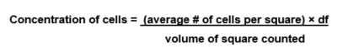
where df = the dilution factor, if the original suspension was diluted, and where
the volume of square counted is in mm³. The dilution factor is the reciprocal of the dilution of the sample.
- Convert the concentration of cells from cells/mm³ to cells/ml, using the following formula:
cells/ml = cells/mm³ × 10³
Note: 1 cm³ = 1000 mm³, and 1 cm³ = 1 ml. The concentration should be expresses in exponential format, e.g. 1.34 × 10⁷ cells/ml.

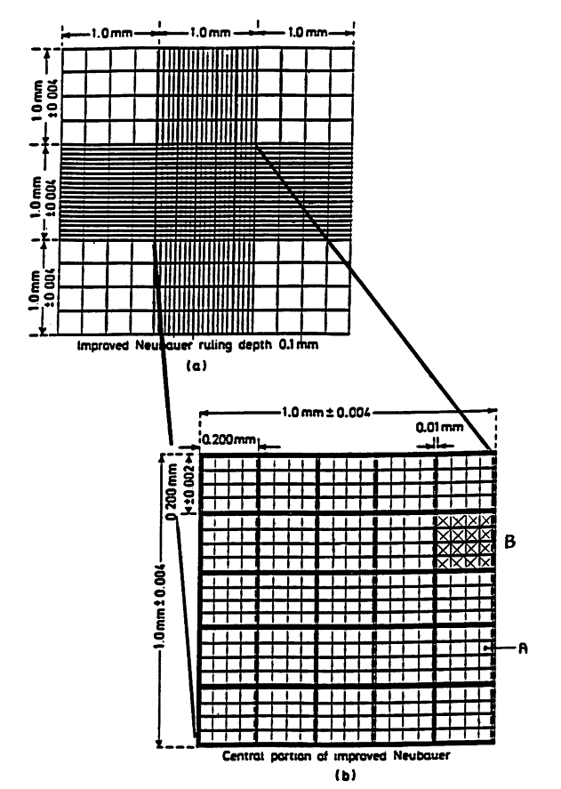

Figure 1. The improved Neubauer haemocytometer. (a) The whole counting grid, and (b) the central counting area of the grid. Note: (1) The grid has a ruling depth of 0.1 mm, (2) square A has an area of 0.0025 mm² and square B (shaded) has an area of 0.04 mm², and (3) the ruling depth and the area of the smallest squares are engraved on the haemocytometer.

EXPERIMENT 2: Preparation of a decimal serial dilution

Background
Techniques used for quantifying microorganisms generally require that the microorganisms be present within a predetermined concentration range. The accuracy and relevance of most quantifying techniques decreases when the microorganisms are present in a concentration outside the desired concentration range. If the microorganisms are present in too high a concentration, the counts are likely to be inaccurate due to the inability of the technique to differentiate between individual cells. Similarly, if the microorganisms are present in too low a concentration, the results are likely to be subject to chance fluctuations and thus be statistically insignificant. If the microorganisms are present in a concentration greater than the desired concentration range, the concentration of cells needs to be reduced. Dilutions are used to reduce the number of cells per volume of culture or suspending liquid. Dilutions are prepared by transferring a known volume (usually small) of a microbial suspension to a known volume (usually large) of diluent. Decimal serial dilutions are serial dilutions in which the dilution factor is 10 or a multiple of 10.

Basic rules for the preparation of dilutions
- The amount of dilution of a sample can determined by using the following formula:
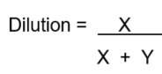
where X is the volume of the original sample transferred, and Y is the volume of the dilution blank.
For example, when 1 ml bacterial suspension is transferred to a 9 ml saline blank,
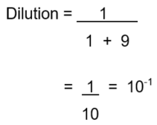
- The microbial concentrations are almost always expressed as the number of cells per millilitre, i.e. cells/ml.
- The number of cells is expressed in the exponential format, e.g. 1 x 10⁶ cells/ml.
- The dilution factor is the reciprocal of the dilution of the sample. For example,
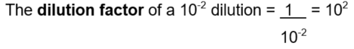

Demonstrations by Teaching Assistants
The Teaching assistants will demonstrate the following techniques:
- The correct pipetting technique.
- The aseptic transfer of liquid between containers (in this case, between bottles and test tubes and between test tubes).
Materials
24-hour broth culture of Escherichia coli
1 ml pipettes
10 ml pipettes
Bottle normal saline
5 test tubes

Procedure
Note: The experiment is summarized in Figure 2. You need to work accurately and aseptically.
- The E. coli culture has been labeled as number 1. Label the test tubes with the numbers 2 to 6.
- Add 9.9 ml saline to test tube 2 and 9.0 ml saline to test tubes 3 to 6.
- Mix the E. coli culture (tube 1) by rolling the tube between the palms of your hands to ensure the even dispersal of cells in the culture.
- Using a sterile 1 ml pipette, aseptically transfer 0.1 ml of the bacterial suspension in tube 1 to tube 2. Discard the pipette in the receptacle provided.
- Mix tube 2 and with a fresh pipette transfer 1.0 ml to tube 3. Discard the pipette.
- Mix tube 3 and with a fresh pipette transfer 1.0 ml to tube 4. Discard the pipette.
- Mix tube 4 and with a fresh pipette transfer 1.0 ml to tube 5. Discard the pipette.
- Mix tube 5 and with a fresh pipette transfer 1.0 ml to tube 6. Discard the pipette.
- This dilution series will be used for Experiments 3 and 4.

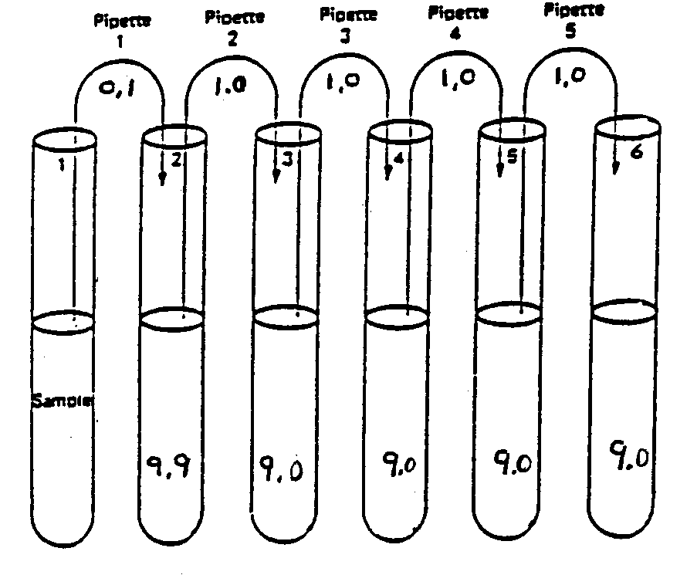
Figure 2. Graphical representation of the decimal serial dilution to be prepared in Experiment 2.

EXPERIMENT 3: The pour plate method
Background
The pour plate technique is used to obtain isolated colonies of bacteria and is used primarily for colony counts. The original sample is usually diluted several times to reduce the microbial population sufficiently to obtain separate colonies upon plating. The small volumes of several diluted samples are added to sterile petri dishes and mixed with liquefied solid medium that has been cooled to about 50 to 55°C. Most bacteria and fungi will not be killed by the brief exposure to the warm agar.

Demonstrations by Teaching Assistants
The Teaching assistants will demonstrate the correct pour plate method.

Materials
Decimal serial dilutions (10⁻², 10⁻³, 10⁻⁴, 10⁻⁵, 10⁻⁶; see Experiment 2 above)
Molten nutrient agar (NA) tubes in a 55ºC water bath (10 ml/per tube)
1 ml pipettes
5 petri dishes per pair

Procedure
1. Make sure that the plates are labeled with your name and the dilution/dilution factor on the bottom (the base) of the petri dish.
2. Starting with the highest dilution (i.e. 10⁻⁶), pipette 1.0 ml amounts of each dilution into a sterile petri dishes.
3. Pour 10 ml molten NA into each dish. Mix by gently moving the plate while flat on the bench, in a combination of sideways and circular movements in alternatively clockwise and anticlockwise direction. Do not spill agar on the bench or on the lid of the petri dish.
4. Incubate the petri dishes at 37ºC for 24 to 48 hours.
5. Determine the concentration (cells/ml) in the original undiluted suspension. This should be done is your own time using the following method:
- Retrieve the five plates and arrange them on the desk top according to dilution.
- Select the plates that have more than 30 but less than 300 colonies to count. Plates with >300 colonies cannot be counted and designated as TNTC (too numerous to count) whereas plates with fewer than 30 colonies are designated TFTC (too few to count). Count both surface and subsurface colonies.
- The number of cells per millilitre in the original undiluted suspension is given by the following formula:
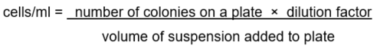
Note: If more than one plate is counted, take the average of the counts.

EXPERIMENT 4: The spread plate method
Background
The spread plate or surface viable count technique is used to obtain isolated colonies of bacteria and is used for colony counts and pure culture isolation. Like the pour plate method, the original sample is usually diluted several times to reduce the microbial population sufficiently to obtain separate colonies upon plating. In contrast to the pour plate, the suspension is plated on solidified agar in a petri dish. The surface viable count method is often used to count cells which grow best on the surface of the medium, i.e. cells that are strongly aerobic.

Demonstrations by Teaching Assistants
The Teaching assistants will demonstrate the following techniques:
- The sterilization of the glass spreader.
- The correct spread plate technique.
Materials
Decimal serial dilutions (10⁻², 10⁻³, 10⁻⁴, 10⁻⁵, 10⁻⁶; see Experiment 2 above)
1 ml pipettes
5 Nutrient agar (NA) plates
Glass spreaders
Alcohol

Procedure
- Make sure that the plates are labeled with your name and the dilution/dilution factor on the bottom (the base) of the petri dish.
- Starting at the highest dilution, pipette 0.1 ml of each dilution on the agar surface of different NA plates.
- For each plate, spread the inoculum evenly over the entire NA surface. Important: Before and after spreading the inoculums, sterilize the glass spreader. The glass spreader is sterilized by:
- Dipping the spreader into alcohol (in a glass petri dish).
- Letting excess alcohol drip off the spreader.
- Igniting the remaining alcohol on the spreader by passing the spreader through the Bunsen burner flame and allowing the alcohol to burn.
- Leave the plates on the bench for at least 15 minutes to allow the water from the inoculum to be absorbed.
- Incubate the plates at 37°C for 24 to 48 hours.
- Count the number of colonies on the surface of the NA plates and determine the concentration (cells/ml) in the original undiluted suspension. This should be done is your own time using the procedure outlined in Experiment 3 above.

Laboratory report and mark allocation for the Practical

IMPORTANT: The laboratory report for Experiment 1 must be submitted before you leave the practical.

Experiment 1
Calculate the number of cells/ml of the undiluted suspension. Show all your calculations.
(10 marks)

Experiment 2
The accuracy of your serial dilutions will be evaluated (by examining your pour plates and spread plates). (10 marks)

Experiment 3
- Your pour plates will be evaluated and marks allocated for the quality of your pour plates. (10 marks)

- Calculate the number of cells/ml of the original undiluted suspension. Show all your calculations. (5 marks)

Experiment 4
- Your spread plates will be evaluated and marks allocated for the quality of your spread plates. (10 marks)

- Calculate the number of cells/ml of the original undiluted suspension. Show all your calculations. (5 marks)

TOTAL MARKS = 50

PRACTICAL: BACTERIOPHAGES
INTRODUCTION
Bacterial viruses (‘bacteriophages’ or ‘phages’) are viruses that infect bacteria. Virulent phages infect and replicate in actively growing bacterial host cells, causing the cell to lyse thereby releasing infective phages. This is known as the lytic cycle. Temperate phages on the other hand are capable of either lytic growth or an alternative lysogeny cycle, where the phage inserts its genetic material into the host cell genome, thereby becoming a latent ‘prophage’.

The use of virulent phages in a plaque assay can be used to illustrate the general principles involved in the detection and enumeration of viruses. A known volume of phage sample is mixed with susceptible bacterial cells in molten soft agar medium and poured on top of the same medium. The phages diffuse through the soft top layer and attach to susceptible cells which will lyse to create a clear area (plaque) within the “lawn” of bacteria. Each plaque represents the lysis of bacterial cells from a single phage and is represented as a plaque forming unit (pfu). A count of the number of plaques can be used to give the number of phages in a particular sample i.e. pfu/ml. In the plaque assay, serial dilutions of the bacteriophage are made and used to infect a standard concentration of bacterial cells. The number of phage particles in the original stock phage culture is determined by counting the number of plaques formed on the seeded agar plate and multiplying this by the dilution factor. For a valid phage count, the number of plaques on a plate should fall between 30 and 300. Plates showing greater than 300 pfus are too numerous to count (TNTC) and plates showing fewer than 30 pfus are too few to count (TFTC).

AIMS: TO CALCULATE ORIGINAL BACTERIOPHAGE TITER IN STOCK CULTURE AND COMPARE PLAQUE MORPHOLOGY BETWEEN TWO PHAGES (K12 AND 25922)

MATERIALS:
Phage K12p and Phage 25922p
4 hour Escherichia coli culture (4 mL)
6 tubes containing 9 ml of Tryptic soy broth (TSB)
8 tubes containing 3 ml of molten TSA (found in the 60 ºC waterbath)
8 TSA plates
P1000 and P100 micropipettes
Sterile tips

PROCEDURE:
- Label 3 tubes containing TSB 10⁻¹ to 10⁻³. These will be used for the serial dilution of the phage stock provided.
- Pipette 1 ml of the each of the phage stock into the tube labelled 10⁻¹ and mix by rolling the tube between your hands. This forms the first ten-fold dilution (i.e. 1 in 10 dilution).
- Take 1 ml from the 10⁻¹ dilution and pipette into the tube labelled 10⁻². Mix gently by rolling the tube between your hands (hundred-fold dilution).
- Continue this pattern to create a serial dilution series until 10⁻³.
- Label 4 TSA plates 10⁰ to 10⁻³.
- Add 100 µl of diluted phage from the 10⁻³ tube to a tube of molten TSA, then add 300 µl of E. coli cells to the same tube. Mix gently but quickly by rolling between your hands and pour over the plate labelled 10⁻³. Swirl to distribute the agar evenly.
- Leave the plate on the bench to allow the agar to solidify.
- Repeat step 6-7 for each of the dilutions 10⁻² and 10⁻¹ using the appropriate tubes of diluted phage.
- Add 100 µl of each of the undiluted phage (10⁰) to a separate tube of molten TSA, then add 300 µl of E. coli cells to the same tube. Mix gently but quickly by rolling between your hands and pour over the plate labelled 10⁰. Swirl to distribute the agar evenly.
- Leave the plate on the bench to allow the agar to solidify
- Once all the plates have solidified, incubate upside down at 37 ºC for 24 hours.
- Count the number of plaques and fill in the table provided below.

NAME: Student Number:
TA:

RESULTS (15 marks):
- Count the number of plaques on each of the plates and record them in the table below. Remember the counting rule, 30-300 pfus (4 marks)

Dilution | PFU count |  | No. of pfus in 0.1 ml  of original stock |  | No. of pfus/ml in  original phage stock
 | K12 | 25922 | K12 | 25922 | K12 | 25922
10⁰
10⁻¹
10⁻²
10⁻³

- Calculate the number of pfus in 0.1 ml (100 µl) of the original stock and record them in the table above in correct scientific notation. Show one of your calculations. (4 marks)

- Calculate the pfus/ml in the original phage stock. Show one of your calculations.
(4 marks)

- Describe and compare the two types of plaques from the two phages. (3 marks)

PRACTICAL: MORPHOLOGICAL INVESTIGATION OF FUNGI

The fungal kingdom includes some of the most important organisms found on earth. They play a role in our everyday lives, whether in the form of food such as mushrooms and truffles, as model organisms in the study of human disease, or as the producer of antibiotics such as penicillin.
Before the advent of molecular analyses, microbes were taxonomically grouped according to their morphology and physiology. Scientist would compare colour, growth temperature ranges, the ability to ferment certain sugars and the production of specific sexual structures (ascospores, basidiospores); in order to group the vast number of newly discovered microbes. Today, DNA analyses has allowed us to redefine this classification system. The genus Saccharomyces for example originally consisted of 40 species. Today we only recognize seven (7) Saccharomyces species. Despite these advancements however, morphological analyses still remains the first step in the process of identifying and classifying novel fungal species.

Filamentous fungi
The majority of fungi are multicellular and are comprised of long thread-like filaments termed hyphae (Fig 1). These hyphae can be grouped as either septate or non-septate (coencytic). Septate hyphae are divided into individual sections by cell walls, called septa (spetum), which generally contain pores to allow the flow of nutrients and cytoplasmic material. Septa can be useful during the identification of different filamentous fungi. Non-septate hyphae lack these cells walls and as such are often referred to as being multinucleate, as each hyphal filament will contain multiple nuclei.
Overtime multiple hyphae will produce a large interwoven, interconnected fungal mass called a mycelium (Fig 1). Large mycelia are visible to the naked eye and can vary in colour, shape and texture. These features can be used to distinguish different fungal groups.
During periods of stress, filamentous fungi will produce specialized structures for sexual reproduction (Fig 2). These sporocarps (fruiting bodies) are formed from hyphae solely for the production and release of viable spores.

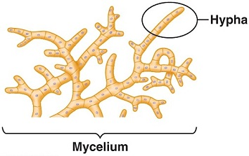
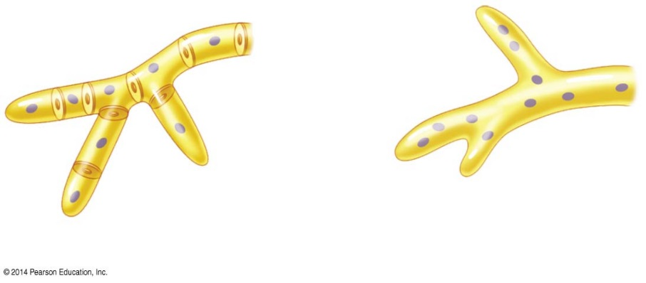
Cell wall
Pore
Septum
Nuclei
Septate hypha
Cell wall
Nuclei
Coenocytic hypha

Figure 1 Genreal micro and macro-morphology of filamentous fungi

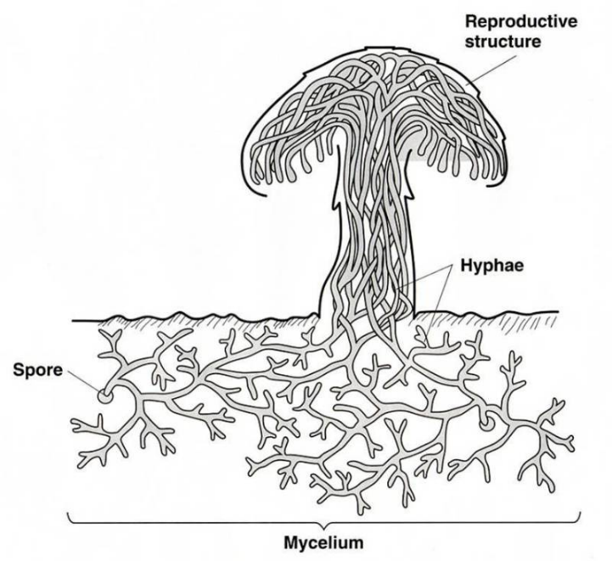

Figure 2 Sporocarp or fruiting body of a basidiomycete fungus

Yeast
Yeast are one of the most important industrial micro-organisms and are involved in the production of amino acids, antibiotics, beer, bread, chemical compounds, vaccines, vitamins and wine. Similarly, yeast are often responsible for food spoilage and diseases in both plants and animals. As such, their identification is important in a number of industries.
Unlike filamentous fungi, yeast are single-celled organisms. Ubiquitous in nature, yeast can be regarded as being globose (round), ovoid, elliptical, apiculate (lemon shaped) or cylindrical. Vegetative growth is achieved by budding, whereby a new daughter cell forms as an outgrowth from the parent / mother cell (Fig 3). This process often-produces bud-scars, where daughter cells have broken off the mother cell. In some cases, buds will become elongated and fail to break away from the parent cell producing pseudo-hyphae (false hyphae).
Bud
(Daughter cell)
Ovoid yeast cell
Budding yeast cell
(Mother cell)
Bud scar
Pseudo-hyphae
Ascus
with 4 haploid ascospores
Ascospore

Figure 3 Micro-morphology of the ascomycetous yeast Saccharomyces cerevisiae

Similar to filamentous fungi, yeast will produce specialized sexual structures and spores during times of stress (Fig 3). The colour, morphology and number of these spores, particularly ascospores, are often used to classify unknown yeast with a specific genus or distinguish between yeast species.
Spores are generally colourless, however; some species such as Nadsonia and Lipomyces do produce amber to light brown coloured spores. The number of spores produced is also important. Nadsonia sp produce a large single ascospore, Schizosaccharomyces octosporus produces eight (8) ascospores, while Kluyveromyces polysporus can produce upwards of 60 ascospores at one time. Lastly, the shape and texture of the spores is often useful. For example, Hansenula capsulate produces hat-shaped spores, while H. saturnus produces spores reminiscent of the planet Saturn.
_____________________________________________________________________________________
Exercise 1
Aim: to identify unknown filamentous fungi based on their macro and micro-morphology

Protocol:
- Work in groups of 2
- You are provided with 4 different filamentous fungal cultures labelled 1 - 4.
- Make notes concerning the macro-morphology (colony morphology) of each culture.
  - Form, elevation, margin, colour, texture, exudates (Appendix 1).
- Prepare a wet mount (Appendix 2) of each fungal culture and examine the micro-morphology with the help of a microscope. Draw and label what you see (100x and 400x magnification).
  - Give special attention to the spore bearing structures, the spores and the morphology of the hyphae.
______________________________________________________________________________
Exercise 2
Aim: to investigate the macro and micro-morphology of known yeast species

Protocol:
- Work in groups of 2
- You are provided with 4 different yeast cultures:
  - Geotrichum candidum, Rhodotorula sp, Saccharomyces cerevisiae and Schizosaccharomyces pombe.
- Make notes concerning the macro-morphology (colony morphology) of each yeast species.
  - Form, elevation, margin, colour, texture (Appendix 1).
- Prepare a wet mount (Appendix 2) of each yeast culture and examine the micro-morphology with the help of a microscope. Draw and label what you see (100x and 400x magnification).
  - Give special attention to the spore structures
______________________________________________________________________________

PRACTICAL REPORTS
Reports are to be handed in at Gate House, ground floor
Due dates: Practical 11: 31st Aug 2018; 14h00

One (1) practical report is to be submitted. (Practical 11). Details for the practical report are given at the end of the practical. Each person is to submit an individual practical report!

REVIEW QUESTION
The answers to your review question are to be handed in at Gate House, ground floor
Due date: 31st Aug 2018; 14h00

“Do you think morphology alone is sufficient for the taxonomic classification of novel fungal species?”

Your answer should be no more than one (1) A4 page (excluding references).
A “Turn-it-in report” must be attached to the submitted review (values should not exceed 20 %).
NB! DO NOT PLAGIARISE! YOU WILL BE GIVEN ZERO (0) AND DISCIPLINARY ACTION WILL BE TAKEN!
No late reports will be accepted and no extensions will be given.

Practical Report
Submit a short report detailing your results. Remember to include:
- Your notes concerning the macro-morphology
- Your labelled drawings of the micro-morphology
- The genus name of the unknown filamentous fungal species which you have identified

Each person is to submit an individual practical report!
Your report is to be submitted no later than 14h00 on the 31 August 2018. No late reports will be accepted and no extensions will be given.

Appendix 1
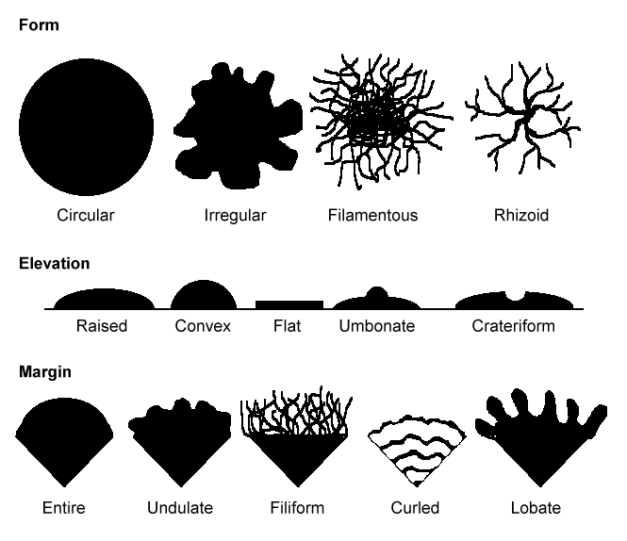

Figure 4 Macro-morphology of fungi

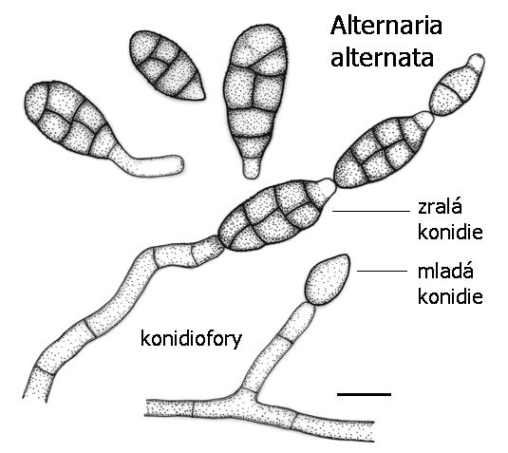
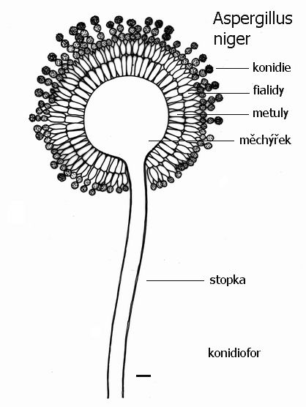
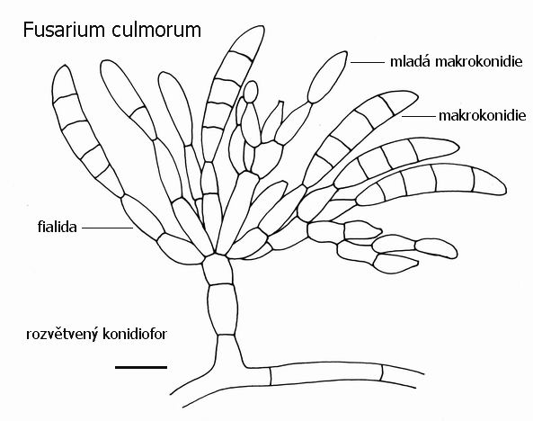
Terminal
conidia
Conidiophore
Mature
conidia
Alternaria alternata
Conidia
Vesicle
Phialide
Metula
Conidiophore
Aspergillus niger
Macro-conidia
Micro-conidia
Phialides
Fusarium sp
Conidiophore

Figure 5 Micro-morphology of some common filamentous fungal species
Adapted from: https://is.muni.cz/do/rect/el/estud/prif/ps06/mikroorg/web/images/plisne/perokresby/?lang=en;ukaznahled=1

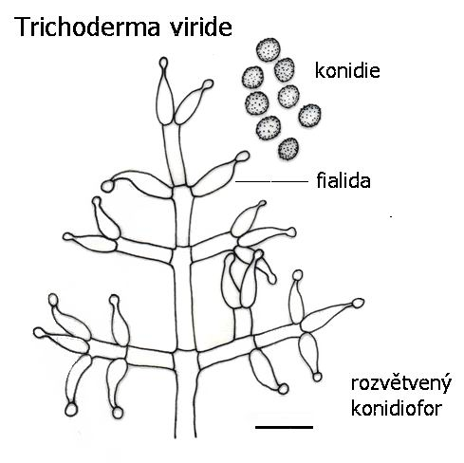
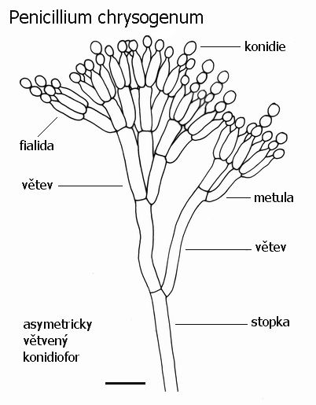
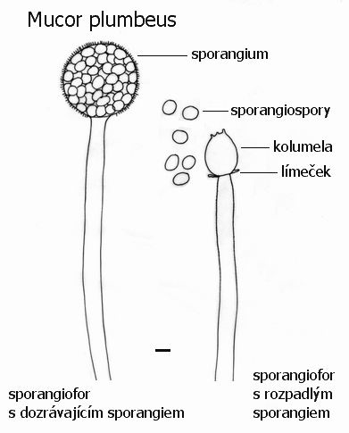
Conidia
Phialides
Conidiophore
Trichoderma sp
Conidia
Metula
Phialides
Conidiophore
Penicillium chrysogenum
Sporangium
Sporangiospore
Columella
Collarette
Sporangiophore
Mucor hiemalis

Figure 6 Cont. Micro-morphology of some common filamentous fungal species
Adapted from: https://is.muni.cz/do/rect/el/estud/prif/ps06/mikroorg/web/images/plisne/perokresby/?lang=en;ukaznahled=1

Asexual reproduction
Sexual reproduction
Ascus
with single haploid ascospore
Ascospore
Arthroconidia / Arthrospores
Hyphae
Geotrichum candidum
Asexual reproduction
Sexual reproduction
Ascus
with multiple haploid ascospores
Light brown
ascospores
Bud
(Daughter cell)
Globose yeast cell
Budding yeast cell
(Mother cell)
Large oil droplet
Lipomyces starkeyi

Figure 7 Micro-morphology of some yeast species
Created by Dr A Botes

Ascus
with large single haploid ascospore
Light brown
ascospore
Bud
(Daughter cell)
Apical yeast cell
Budding yeast cell
(Mother cell)
Asexual reproduction
Sexual reproduction
Nadsonia sp
Ascus
with 4 haploid ascospores
Ascospore
Bud
(Daughter cell)
Ovoid yeast cell
Budding yeast cell
(Mother cell)
Asexual reproduction
Sexual reproduction
Saccharomyces cerevisiae

Figure 8 Cont. Micro-morphology of some yeast species
Created by Dr A Botes

Asexual reproduction
Daughter cells
Cylindrical yeast cell
Cells reproduce
via cell fission
Schizosaccharomyces pombe
Sexual reproduction
Ascospore
Ascus
with 2-4 haploid ascospores
Ovoid yeast cell
Bud
(Daughter cell)
Budding yeast cell
(Mother cell)
Oil droplet
Asexual reproduction
Rhodotorula sp

Figure 9 Cont. Micro-morphology of some yeast species
Created by Dr A Botes

Appendix 2

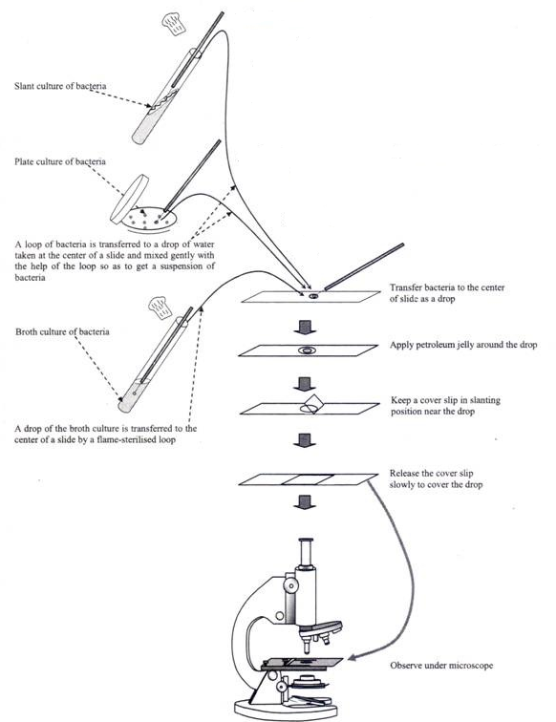

Figure 10 How to prepare a wet mount

PRACTICAL: DEVELOPMENT OF GLEEVEC: A SUCCESSFUL DRUG FOR TREATING CHRONIC MYELOID LEUKAEMIA (CML)

The material presented here has been adapted from the following sources:

http://www.historyofnimr.org.uk/mill-hill-essays/essays-yearly-volumes/2003-2/Gleevec-cml-abl-and-targeted-molecular-therapy-for-cancer/ by Qiling Xu (2003) Mill Hill Essays.
https://www.hindawi.com/journals/cherp/2014/357027/
Nida Iqbal and Naveed Iqbal. Imatinib: A Breakthrough of Targeted Therapy in Cancer. Chemotherapy Research and Practice. 2014, Article ID 357027, 9 pages, http://dx.doi.org/10.1155/2014/357027.
What is Gleevec? How was it discovered?
In Basel, Switzerland, 3 January 2000, the pharmaceutical company Novartis announced that the European Commission approved Gleevec (also known as Imatinib, a 2-phenyl amino pyrimidine derivative) as a first-line treatment for adult and child patients with CML, enabling doctors to provide the drug to newly diagnosed patients. The approval was based on information collected over twelve months in a large study comparing Gleevec with the best previous treatment for CML. Patients treated with Gleevec were nine times more likely to achieve a response in which no cancer cells remained. In other patients Gleevec significantly delayed the time to progression of the more advanced stages of CML. Gleevec was invented in the late 1990s by biochemist Nicholas Lyndon then working for Ciba-Geigy (now Novartis), and its use to treat CML was driven by Brian Druker, an oncologist at the Dana-Farber Institute. The first clinical trial of Imatinib took place in 1998 and the drug received FDA approval in May 2001. Lyndon, Druker, and the other colleagues were awarded the Lasker-DeBakey Clinical Medical Research Award in 2009 for “converting a fatal cancer into a manageable condition” and the Japan Prize in 2012 for their part in “the development of a new therapeutic drug targeting cancer-specific molecules.”
Normal cells produced in the bone marrow develop to maturity in a step-by-step process, until they leave the bone marrow and enter into the blood stream. Among immature bone marrow cells are stem cells that will become red blood cells and different kinds of white blood cells. Leukaemia is an uncontrolled multiplication of the white blood cells. As in many other forms of cancer, the leukemic cells are descended from a single cell that lost its ability to maintain normal control over cell division and growth. There are a number of types of leukaemia, corresponding to the many types of white blood cells and the stages they go through as they mature. CML, arises in a bone marrow cell, which normally forms two types of cells called granulocytes and platelets. So, CML patients have abnormally high numbers of these cells in their blood. Clinically there are three phases of CML depending on the number of immature blood cells in the blood and bone marrow. During the initial chronic phase, the number of immature stem cells is increased but they can still mature to form different white blood cells that function normally. At this stage the patients have mild symptoms and respond to treatment. After an average of four to five years, the CML typically progresses to the accelerated phase, in which there are more immature cells in the blood and the disease is not as responsive to treatment. The final, often fatal stage, is the “blast crisis”, where immature cells dominate and chronic leukaemia has become an aggressive acute leukaemia.

There are three major treatments for CML. Firstly, chemotherapy and radiotherapy can be used to kill cancerous cells but this has the disadvantage that normal cells in the blood are also killed. The treatment offers some relief rather than a cure since the methods are poorly targeted and highly toxic. A second treatment is aimed at improving the body’s immune system to fight the cancer. Interferon alpha is a protein naturally produced in our bodies to fight viruses. In the 1980s interferon alpha was introduced to treat CML in combination with chemotherapy. This treatment has achieved long-lasting remissions in 30% of patients compared with 5% of those using conventional chemotherapy. It does not, however, completely remove the cancer cells. The final treatment option is high-dose chemotherapy and total body irradiation followed by bone marrow transplantation. This is the only treatment capable of disease eradication, but is restricted to patients who can identify a suitable bone marrow donor and who are medically fit to undergo the procedure. The most effective therapy would be one that specifically eliminates the cancer cells. However, such a treatment was not available before scientists had a molecular understanding of the disease.
Human cells have 46 chromosomes, 23 pairs in females, 22 pairs plus 2 unpaired in males. In 1960 two researchers in Philadelphia noticed that an abnormally small chromosome was consistently present in the cells of CML patients. This was given the name of the Philadelphia (Ph) chromosome. This was the first time that a chromosomal abnormality had been associated with a malignant disease. In 1973 the Ph chromosome was found to be the result of swapping parts of chromosome 9 and 22, producing a longer chromosome 9 and a shorter chromosome 22. Two genes flanking the points in the DNA where this swap over occurs were identified in the early 1980s. One is the abl (ablation) gene from chromosome 9 that was already known as the human counterpart of a mouse virus gene. The other gene from chromosome 22 was given the name of bcr (short for breakpoint cluster region). At that time the function of Bcr was unknown, but the abl gene was widely studied. The Abl protein is an enzyme, known as a protein kinase that attaches a phosphate group to specific proteins. When this happens it triggers a cascade of events in the cells that regulate the division of cells and cell death. These are both common mechanisms used to control the number of cells in the body. Cell death is a protection mechanism used to eliminate excess or abnormal cells. Disruption of either of these mechanisms can result in uncontrolled cell division manifested as cancer. Abl protein in normal cells is only enzymatically active when the cell is stimulated by a growth factor. The effect of the Ph chromosome translocation is to bring the bcr and abl genes together resulting in a fused bcr-abl gene. A major breakthrough in understanding the molecular nature of CML came when it was discovered that the fused Bcr-Abl protein produced from the fused gene is a continuously active protein kinase. This unrestrained activation of the kinase activity leads to an increase in the rate of cell division and the protection of the cells from cell death. Consequently, a large number of Ph chromosome-containing cells is found in CML patients.

How Gleevec works?
Tyrosine kinases are important mediators of the signalling cascade, determining key roles in diverse biological processes like growth, differentiation, metabolism, and apoptosis in response to external and internal stimuli. Deregulation of protein kinase activity has been shown to play a central role in the pathogenesis of human cancers. In 1995 and 1996 a few such compounds that specifically inhibited the kinase activity of Bcr-Abl were identified. Gleevec, is a tyrosine kinase inhibitor with activity against Abl, Bcr-Abl, PDGFRA, and c-KIT. The active sites of tyrosine kinases each have a binding site for ATP. The enzymatic activity catalysed by a tyrosine kinase is the transfer of the terminal phosphate from ATP to tyrosine residues on its substrates, a process known as protein tyrosine phosphorylation. Gleevec works by binding close to the ATP binding site, locking it in a closed or self-inhibited conformation, therefore inhibiting the enzyme activity of the protein semi-competitively. This process ultimately results in “switching-off” the downstream signalling pathways that promote leukaemogenesis. Gleevec also inhibits the Abl protein of noncancer cells, but cells normally have additional redundant tyrosine kinases which allow them to continue to function even if Abl tyrosine kinase is inhibited. Some tumour cells, however, have a dependence on Bcr-Abl. Inhibition of the Bcr-Abl tyrosine kinase also stimulates its entry into the nucleus, where it is unable to perform any of its normal anti-apoptotic functions. Gleevec is well absorbed after oral administration with a bioavailability exceeding 90%. It is extensively metabolized, principally by cytochrome P450 CYP3A4 and CYP3A5, and can competitively inhibit the metabolism of drugs that are CYP3A4 or CYP3A5 substrates. Gleevec is generally well tolerated. Common side effects include fluid retention, headache, diarrhoea, loss of appetite, weakness, nausea and vomiting, abdominal distention, oedema, rash, dizziness, and muscle cramps. Serious side effects may include myelosuppression, heart failure, and liver function abnormalities.
Gleevec was referred as a “wonder drug”. However, CML comes in many ugly faces and Gleevec cannot cure them all. When treated during the more aggressive stage of blast crisis, most CML patients ultimately develop a drug-resistant disease. The majority of relapsed patients have mutations within the Bcr-Abl kinase region that reduce or abolish drug binding. The key regions of the kinase required both for regulation of Abl under normal circumstances, and for inhibition of Bcr-Abl by Gleevec, have now been identified. It is of great importance to understand the underlying mechanisms of drug resistance so that a new generation of targeted anti-cancer agents can be designed. The resistance to Gleevec has also led to a renewed interest in other drugs that may be helpful in this situation. These are targeted at the cellular events following the activation of Bcr-Abl, the stability of the Bcr-Abl proteins and alternative inhibitors of Abl kinase.
We are undergoing a revolution in medicine in which a better understanding of mechanisms of disease, such as cancer, and of pathways at the molecular and genetic levels has provided new opportunities for rational therapies and novel approaches for diagnosis. Molecular targets include molecules and pathways that are involved in cell proliferation, programmed cell death, DNA repair and secondary tumour formation. Through genetic testing and gene-based treatment we can anticipate dramatic changes in disease prevention, diagnosis and treatment. As each individual has a unique composition in our genetic make-up, a person-based medical treatment will be a reality in the not too distant future. It is noteworthy that these recent and future advances in our understanding of human diseases are deeply rooted in knowledge of genetics, molecules and pathways that come from basic research. Progress in understanding the molecular biology of different types of leukaemia is the key to the development of accurate diagnosis and targeted treatment. Gleevec has set a precedent for the approach of molecularly targeted therapy and has demonstrated that it is pivotal to identify the right target for the right group of patients.

Practical exercise:
Go to website: https://www.learner.org/courses/biology/casestudy/cancer.html
Click on “Launch case study” to start the exercise and follow the instructions on the screen. Complete the exercise and answer the questions in the assignment below. Hand it over to your TA before leaving the lab.

Practical Report (MCBG 2036, Drug Discovery)

Development of Gleevec: a successful drug for treating Chronic Myeloid Leukaemia (CML)

Lecturer: Prof Mandeep Kaur Total Marks: 20

Person Number____________________ TA______________________ Date:
1. Draw the structure of Gleevec? (1 mark)

2. Which chromosomal mutation is responsible for CML? In how many patients this mutation is detected? (3 marks)

3. What is IC50 in terms of enzyme activity? (1 mark)

4. What are the IC₅₀’s of compound 3 against Abl enzyme and mutant Bcr-Abl, when selected tyrosine mimic as a lead compound? (2 marks)

5. Out of phosphate, methypiperizine and isoprene, which group was used modify ATP lead compound and why? (2 marks)

6. During development of Gleevec, it was found to be active against Bcr-Abl at lower concentrations but inhibited PKA kinases at higher concentrations.
Would this observation make Gleevec a good drug candidate? Answer in ‘yes’ or ‘no’ and justify your answer. (3 marks)

7. Gleevec is a very successful drug against CML. But it has been observed that many CML patients do not respond to Gleevec. (8 marks)
a) At what disease stage and why some patients do not respond to Gleevec? Describe molecular mechanisms involved. (5 marks)

b) Which cellular processes can further be targeted to develop new drugs for CML? (3 marks)

PRACTICAL: MEASURING CELL DEATH USING TRYPAN BLUE EXCLUSION METHOD IN RESPONSE TO TREATMENT WITH A COMPOUND IN A TIME-COURSE EXPERIMENT

Purpose
This document describes the procedure to measure cell death in the culture using the Trypan blue exclusion method.

Safety Precautions
1. Good laboratory techniques are to be used at all times.
2. Any material that has been in contact with human, murine, or GM cell lines is treated as potentially infectious.
3. Wear gloves and lab coat at all times.
Introduction
The dye exclusion method is used to determine the number of viable cells present in a cell suspension. It is based on the principle that live cells possess intact cell membranes that exclude certain dyes, such as trypan blue, Eosin, or propidium. Trypan blue is a diazo dye, synthesized by the German scientist Paul Ehrlich in 1904, selectively colour dead cells blue. It is excluded from live but accumulates in dead cells, is one of the most commonly used methods for assessment of viability in a given cell population. It traditionally requires time-consuming cell counting, a method prone to investigator bias and sampling error. By automating this method using spectrophotometry, it provides an attractive method to rapidly quantify dying cells in the cell culture.

EXPERIMENT
The purpose of this laboratory exercise is to acquaint you with some of the fundamentals of culturing cells in vitro.
(1) What do cell cultures look like?
(2) Where do the cells grow?
(3) What do the cells in the culture look like?
In this exercise you will:
(1) Observe the cell culture provided;
(2) Determine the percentage of cell death.

MATERIALS
- 0.4% Trypan Blue stain (fresh & filtered) in phosphate buffered saline.
- 1% SDS.
- 1x PBS.
- MCF7 (oestrogen receptor positive (ER+) breast cancer) cells grown in a 96-well plate.
- Micropipettes and tips.
- Inverted microscope.
- Spectrophotometer- plate reader

PROCEDURE
1. Visualize cells under microscope
Each group will receive a 96-well plate with 5000 cells cultured in it. You will go in groups to visualize the plate under a microscope. Focus the microscope using knobs and see cells under 10X. Take note of the distribution and morphology of cells in each plate. Note down what you have observed and answer the questions in the assignment.

2. Treating the cells with a chemical and performing the assay
The cells will be treated with one concentration of the given chemical over time-intervals. We are performing a time-course experiment to see how a particular concentration of a chemical affects living cells over time. This will also help us to identify time-frame in which drug starts to kill cancer cells and in how much time it can kill approximately 50% of the cells.
Following is the chemical treatment plan in a 96-well plate:

Column1 | 2 | 3 | 4 | 5 | 6 | 7 | 8 | 9 | 10 | 11 | 12
Blank | SDS only | SDS only | SDS only
Untreated | 0 | 0 | 0
90 minutes | - | - | -
60 minutes | - | - | -
30 minutes | - | - | -
10 minutes | - | - | -

Blank- Contains solution only that will be used for absorbance measurement, in this case it is SDS.
Untreated- Contains cells which have not been treated with any chemical.
90 minutes- cells that have been treated with the chemical for 90 minutes.
60 minutes- cells that have been treated with the chemical for 60 minutes.
30 minutes- cells that have been treated with the chemical for 30 minutes.
10 minutes- cells that have been treated with the chemical for 10 minutes.
a. The cells were grown in 50 μl of media, incubated overnight at 37 °C in a CO₂ incubator.
b. Add 10 μl of provided chemical (by touching the tip on the walls of the well) in columns 2, 3 and 4. First add chemical in ’90 minutes’ sample, start incubation at 37 °C, after 30 minutes add chemical in ’60 minutes’ sample and repeat the process of incubation and treating again till you finish all chemical treatments (10 minutes per sample).
Do not add the chemical to wells for ‘Untreated’. Makeup the required volume by adding 10 μl PBS (total in the well should be 60 μl).
c. Incubate at 37 °C for required time.
d. Add 60 μl of sterile 0.4% trypan blue solution to all the samples and untreated wells (except blank) and incubate the in the incubator (37 °C) for 15 minutes.
e. Remove dye containing media via gentle but thorough washing (3×100 μl) with (0.01 M PBS). A slow, steady wash is necessary to prevent loss of dead cells which may result from mechanical handling.
f. Look the plate under the microscope. Visual analysis of the cultures will reveal an admixture of live (trypan blue negative) and dead (trypan blue positive) cells in each experimental condition.
Notice the difference in the number of cells stained blue at each time-point.
g. Add 100 μl of sodium dodecyl sulphate (SDS; 1% w/v) to all the sample wells, untreated wells and blank wells, and mix the contents gently taking care not to introduce air bubbles.
h. Take OD (optical density) spectrophotometrically using a plate reader at 590 nm.
3. Calculations
1. Take mean of three OD values for each sample, blank and untreated.
2. Subtract mean of blank from mean of samples and untreated. Result is the final mean.
3. Calculate percent cell death
Percentage change in cell death in treated as compared to untreated:
(Sample - Untreated) x 100
Untreated
4. Draw a histogram using Percentage change in cell death on Y-axis and time points used in experiment on the X-axis.

Practical Report (MCBG_2036, Drug Discovery)
Measuring cell death using trypan blue exclusion method in response to treatment with a compound in a time-course experiment.

Lecturer: Prof Mandeep Kaur Total Marks: 20
Person Number____________________ TA______________________ Date:
1. Draw a labelled histogram using Percentage change in cell death on Y-axis and time points used in experiment on the X-axis. (7 marks)
a. Paste histogram here (4 marks)

b. What does this graph tell about the experiment? (1 mark)

c. How would you interpret the results presented in this graph? (2 marks)

2. What is the principle behind trypan blue exclusion Test of cell viability?
(1 mark)

3. You have seen cells under microscope. Answer the following using your observation:
(2 marks)
a. What is the confluency of cells in the plate? Write your answer in percentage.

b. What is the morphology of the cells that you have observed under the microscope?

4. Why do we need to use a blank and a negative control (untreated sample)? (2 marks)

5. In the following diagram, a comparison of different compounds ‘SK’ compounds is presented in two different cell lines. The cytotoxicity of ‘SK’ compounds were tested on two different breast cancer cell lines, namely; oestrogen receptor positive (ER+) MCF-7 cells and triple negative MDA-MB-231 cells (ER-) using an MTT (3-(4,5-Dimethylthiazol-z-yl)-2,5-diphenyltetrazolium bromide) cell viability assay (assay that helps to quantify alive cells). Y-axis shows the percentage of cells inhibited (growth inhibition) and X-axis shows the compounds and the cell lines. The legend on the side shows different concentrations of each compound tested. (8 marks)

a. In which cell line the compounds were most active in general? (1 mark)

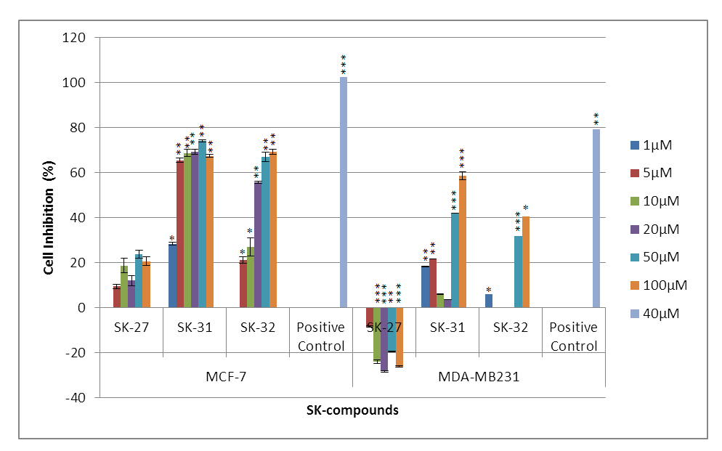
b. Compare the activity of each compound in two different cell lines and explain which compound is most active in which cell line? Keep into account the concentrations used while explaining your answers. (2 marks)

c. Out of the three compounds tested, which compound do you think is the most promising lead for further development for treating oestrogen-positive breast cancer? How activity of this compound can be increased? Justify your answer. (3 marks)

d. The compound SK-27 is only active against ER+ MCF-7 cells while MDA-MD-231 cells do not respond to SK-27. What this could tell about the mechanism of action of this compound in both types of cells? (2 marks)

PRACTICAL: QUANTIFYING APOPTOTIC DEATH IN CANCER CELLS USING APOPercentage ASSAY

Purpose
This document describes the procedure to measure apoptotic cell death in the culture using the APOPercentage dye.
Introduction
Following information has been taken from freely available resources listed below: https://www.ncbi.nlm.nih.gov/books/NBK26873/
http://www.abcam.com/kits/introduction-to-apoptosis
http://www.biotechniques.com/BiotechniquesJournal/2008/September/A-low-cost-flow-cytometric-assay-for-the-detection-and-quantification-of-apoptosis-using-an-anionic-halogenated-fluorescein-dye/biotechniques-45310.html
The cells of a multicellular organism are members of a highly organized community. The number of cells in this community is tightly regulated—not simply by controlling the rate of cell division, but also by controlling the rate of cell death. If cells are no longer needed, they commit suicide by activating an intracellular death program. This process is therefore called programmed cell death, although it is more commonly called apoptosis (from a Greek word meaning “falling off,” as leaves from a tree).
Apoptosis (Fig 1) is a form of cell death, also known as programmed cell death, in which a ‘suicide’ program is activated within the cell, leading to fragmentation of the DNA, shrinkage of the cytoplasm, membrane changes and cell death without lysis or damage to neighbouring cells as cells are engulfed by phagocytes (macrophages). It is a normal phenomenon, occurring frequently in a multicellular organism.
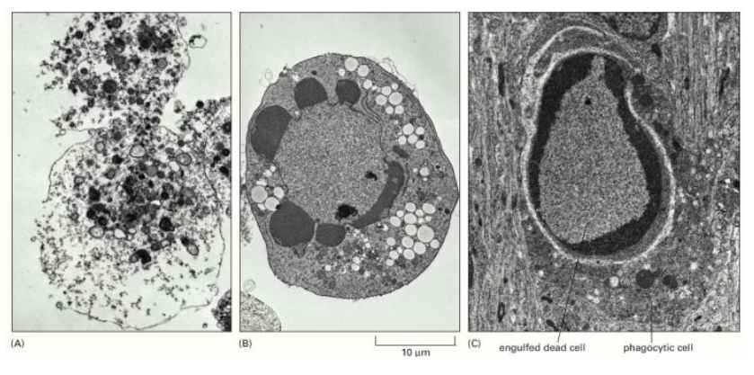
Fig 1: These electron micrographs show cells that have died by (A) necrosis or (B and C) apoptosis. The cells in (A) and (B) died in a culture dish, whereas the cell in (C) died in a developing tissue and has been engulfed by a neighbouring cell. Note that the cell in (A) seems to have exploded, whereas those in (B) and (C) have condensed but seem relatively intact. The large vacuoles visible in the cytoplasm of the cell in (B) are a variable feature of apoptosis. (Courtesy of Julia Burne.) From: Programmed Cell Death (Apoptosis), Molecular Biology of the Cell. 4th edition. Alberts B, Johnson A, Lewis J, et al. New York: Garland Science; 2002.

Apoptotic mechanism
During apoptosis, a family of cysteine-aspartate proteases known as caspases accelerates cell death through restricted proteolysis of over 400 proteins. The two main pathways through which this cell death process is initiated are the intrinsic and extrinsic cell death pathways, both converging on caspase activation.
The intrinsic cell death pathway is governed by the Bcl-2 family of proteins, which regulate commitment to cell death through the mitochondria. A myriad of intracellular death signals are communicated through the intrinsic cell death pathway, such as DNA damage, oncogene activation, growth factor deprivation, ER stress and microtubule disruption. The key step in the intrinsic cell death pathway is the permeabilization of the mitochondrial outer membrane, which has been identified as a ‘point of no return’ after which cells are committed to cell death. Following permeabilization, release of various proteins from the mitochondrial intermembrane space promotes caspase activation and apoptosis. Cytochrome C binds APAF-1 (apoptosis protease-activating factor 1), inducing its oligomerization and thereby forming a structure called the apoptosome that recruits and activates an initiator caspase, caspase 9. Caspase 9 cleaves and activates the executioner caspases, caspase 3 and 7, leading to apoptosis.
Activation of the extrinsic cell death pathway occurs following the binding on the cell surface of “death receptors” to their corresponding ligands such as Fas, TNFR1 or TRAIL. These death receptors have two distinct signalling motifs, death domains (DD) and death effector domains (DED), that allow them to interact and recruit other adaptor molecules such as Fas-associated death domain protein (FADD) and caspase 8, which can then directly cleave and activate the executioner caspases, caspase 3 and caspase 7, leading to apoptosis.
Crosstalk between the extrinsic and intrinsic pathways occurs through caspase 8 cleavage and activation of the BH3-only protein BID (BH3-interacting domain death agonist), the product of which (truncated BID, known as tBID) is required in some cell types for death receptor-induced apoptosis.
Parameters of apoptosis
Apoptosis occurs via a complex signalling cascade that is tightly regulated at multiple points, providing many opportunities to evaluate the proteins involved. The image below (Fig 2) shows the main parameters of apoptosis and the approximate relative time when they are likely to be detected.
Fig 2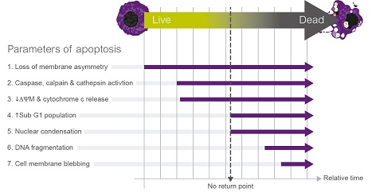

These parameters do not happen in a sequential order, and many of them will overlap and occur at the same time. Loss of membrane asymmetry or initiation of caspase cascade are biochemical features of apoptosis which do not necessarily lead to cell death. However, other downstream features such as decrease of the mitochondrial membrane potential (ΔΨm) and concomitant release of cytochrome C into the cytosol are generally considered points of no return, after which it is very unlikely the cell will survive. Some of these biochemical and morphological features associated with apoptosis can also be observed in other types of cell death such as necrosis or necroptosis. Therefore, it is recommended to analyse more than one parameter to identify apoptosis as a cause of death in the studied population.
APOPercentage Aassay
In viable cells, the distribution of phospholipids between the inner and outer leaflet of the plasma membrane is asymmetric. In this asymmetric distribution, phosphatidylcholine and sphingomyelin are predominantly located in the outer leaflet, while phosphatidyl-thanolamine and phosphatidylserine (PS) are found in the inner plasma membrane leaflet. However, during apoptosis PS translocates to the outer plasma membrane leaflet and can thus be used as a biomarker to identify apoptotic cells.
The APOPercentage assay (Biocolor Ltd., UK), detects apoptosis at the stage when PS is externalized. The APOPercentage assay makes use of an anionic halogenated fluorescein dye, the disodium salt of 3, 4, 5, 6,-tetrachloro-2′, 4′, 5′, 7′-tetraiodofluorescein (TCTF), which is taken up by apoptotic cells, which gives such cells a purple-red appearance. Dye uptake can be visualized by bright-field microscopy and quantified by spectrophotometric measurement at 550 nm.
Safety Precautions
1. Good laboratory techniques are to be used at all times.
2. Any material that has been in contact with human, murine, or GM cell lines is treated as potentially infectious.
3. Wear gloves and lab coat at all times.

MATERIALS
- APOPercentage dye (light sensitive).
- 1x PBS.
- Compounds: Hydrogen Peroxide (H₂O₂) , Acetyl Plumbagin (AP), Ethylenediaminetetraacetic acid (EDTA)
- MCF7 (estrogen receptor positive (ER+) breast cancer) cells grown in a 96-well plate.
- Aluminium foil.
- Micropipettes and tips.
- Inverted microscope.
- Spectrophotometer - plate reader

PROCEDURE
1. Visualize cells under microscope
Each group will receive a 96-well plate with 5000 cells cultured in it. You will go in groups to visualize the plate under a microscope. Focus the microscope using knobs and see cells under 10X. Take note of the distribution and morphology of cells in each plate. Note down what you have observed and answer the questions in the assignment.

2. Treating the cells with a chemical and performing the assay
The cells will be treated with different concentrations of the various compounds. Following is the chemical treatment plan in a 96-well plate:

Column1 | 2 | 3 | 4 | 5 | 6 | 7 | 8 | 9 | 10 | 11 | 12
Blank | PBS only | PBS only | PBS only
Untreated | 0 | 0 | 0
10 mM H₂O₂ | - | - | -
50 mM H₂O₂ | - | - | -
50 μM AP | - | - | -
15 mM EDTA | - | - | -

Blank- Contains solution only that will be used for absorbance measurement, in this case it is PBS.
Untreated- Contains cells which have not been treated with any chemical.
Treated- Four sample concentrations of compounds shown above in the table.
a. The cells were grown in 45 μl of media, incubated overnight at 37 °C in a CO₂ incubator.
b. Add 5 μl apoptotic inducer drug/compound as shown in table (by touching the tip on the walls of the well) in columns 2, 3 and 4.
Do not add the chemical to wells for ‘Untreated’. Makeup the required volume by adding 5 μl PBS (total in the well should be 50 μl).
c. Incubate at 37 °C for required time.
d. Discard the medium.
e. Add 100 μl of dye (0.5 μl of dye diluted in 99.5 μl PBS) and cover the plate with foil.
f. Incubate (37 °C, 5% CO₂) for 15 minutes and check under microscope if cells in EDTA treated wells are pink.
g. Discard the reagent mixture from all wells.
h. 1 x 100 μl PBS wash (Gently by the walls of each well as cells may be loose).
i. Discard the PBS
j. Add 100 μl PBS into each well (prevent drying out of the cells).
Look the plate under the microscope. Visual analysis of the cultures will reveal an admixture of live (clear cells) and apoptotic (pink dye stained) cells in each experimental condition. Notice the difference in the number of cells stained pink in each sample.
k. Take OD (optical density) spectrophotometrically using a plate reader at 550 nm.

Sample pictures
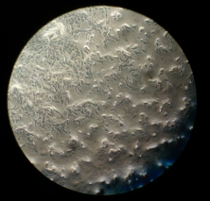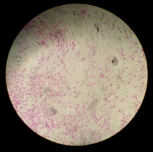
Untreated Treated (10 μM Plumbagin for 24 hours)
3. Calculations
1. Take mean of three OD values for each sample, blank and untreated.
2. Subtract mean of blank from mean of samples and untreated. Result is the final mean.
3. Calculate percent cell death
Percentage change in cell death in treated as compared to untreated:
(Sample - Untreated) x 100
Untreated
4. Draw a histogram using Percentage change in cell death on Y-axis and time points used in experiment on the X-axis.

Practical Report (MCBG 2036, Drug Discovery)
Measuring cell death using trypan blue exclusion method in response to treatment with a compound in a time-course experiment.

Lecturer: Prof Mandeep Kaur

Total Marks: 20

Person Number____________________ TA______________________ Date:
1. Draw a labelled histogram using Percentage change in cell death on Y-axis and drug concentrations used in experiment on the X-axis. (4 marks)
Paste the histogram here

2. How APOPercentage dye detects cells undergoing apoptosis?
(2 marks)

3. Some cells in untreated sample may take up dye and are coloured pink? Give your reasons for following scenarios: (2 marks)
a. About 10% cells are stained pink in the untreated sample.

b. About 50% cells are stained pink in the untreated sample.

4. Explain the results you have obtained in this experiment by analysing histogram. (4 marks)

5. List three more hallmarks of apoptosis which can be targeted using various assays to confirm the apoptotic cell death. (3 marks)

6. Various concentrations of a test compound were given to MCF-7 cells for 24 hours. Plumbagin was used as a positive control. The percentage change of apoptotic cell death is presented on the Y-axis. Answer following questions based on data presented in the graph: (3 marks)

a. What will be the estimated IC₅₀ of the test compound? (1 mark)

b. Do you think that the test compound can be a better lead molecule than a known anticancer compound ‘Plumabgin’ which is also toxic to normal cells? Justify your answer according to concentrations used and toxicity profiles. (2 marks)

7. Explain why apoptotic cell death is a good target for drug development? (2 marks)

